Modern History 112 Course Outline
J. Standring
Visit www.jstandring.weebly.com
There you will find all the notes you need, assignments, due dates, a place to digitally hand in assignments.
Rule 1: Do not email me an assignment. Such action leads to excuses such as: “I emailed it to you. I don’t know why you didn’t get it.” Go to the website above and submit your assignment using the form on the main page.
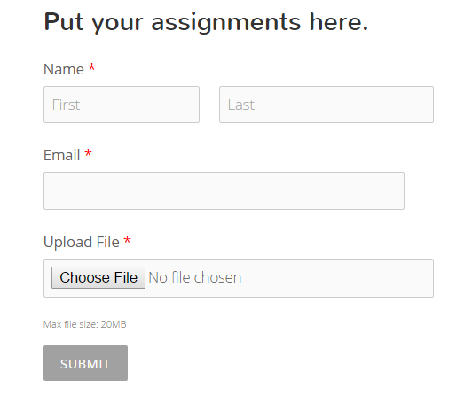
Rule 2: Hand in your work on time. Absent that day? Hand it in early. Plan ahead, get it done before the due date.
Rule 3: Be good to everyone around you. Whether it is the principal or Prime Minister, best friend or burger flipper at McDonald’s; remember the burger flipper is alone with your food. Treat everyone well.
Marking Scheme:
20% Formative: class discussion, chapter questions, group work, quizzes. Everyday class stuff.
50% Summative: Tests, Assignments
30% Exam
Marking Class Discussions: I use an app called Class Dojo. I will issue you a sign-up code, that will allow you to track how often you are responding appropriately, how often you are off task, etc.
Chapter Questions: The mark for these varies. Often they are marked for comprehension (right/wrong), other times they are marked for completion (did you do the work?)
Group Work: Each person is assessed in group work. I will use the class dojo app for informal observations. Students will be given an opportunity to provide feedback on group members as well.
Quizzes: Students will not always be provided notice as to when a quiz will take place. These will be marked for comprehension.
Tests: Questions for tests are created based on the outcomes in the curriculum. They are usually short/long answer and designed to show a grasp of the outcomes and content. Occasionally there are multiple choice or matching questions, but those are limited to vocabulary recognition.
Assignments: Students will complete 3 major assignments. One of which must be a research paper, presenting a historical point-of-view/perspective. Other assignments may take the form of presentations, or created works.
FYI: It is important that students provide evidence to support their arguments and equally important that they credit all sources.

Your Outcome Checklist
Outcome | Check (√)
UNIT 1: Rights and Revolution
1.1.1 Identify and understand the general causes of revolutions: new ideas, social conflict, political factors, and economic conditions.
1.1.2 Know, understand and be able to explain the new ideas of the Enlightenment
1.1.3 Analyze elements of social conflict in 18th century France.
1.1.4 Understand, and be able to explain, how and why France‘s Absolute Government functioned without the consent of the governed.
1.1.5 Comprehend the severity of economic conditions as contributing factors to the revolution.
1.2.1 Understand historians‘ criteria for measuring historical significance
1.2.2 Critically assess the significance of the French Revolution
1.3.1 Make connections to allow comparison of the French Revolution to other modern events in the context of rights and freedoms.
2.1.1. Know, understand and be able to explain the new ideas and innovations which led to the Industrial Revolution.
2.1.2. Analyze elements of social change/conflict during the Industrial period.
2.1.3. Understand, and be able to explain, how governments and workers responded to issues of industrialization.
2.1.4. Comprehend the economic conditions which led to industrialization and furthered its development.
2.2.1 Demonstrate their understanding of the immediate and long term impact of urbanization on society during the Industrial period.
2.2.2 Be able to explain the evolution of worker‘s rights, and the implications of these rights, for workers then and now.
2.3.1 Compare and contrast one aspect of the Industrial period with a modern, evolving industrialized society.
UNIT 2: War and Violence
3.1.1 Know, understand and be able to express examples of power relationships and rivalries between European nations, as causes of the First World War (1860s to 1914).
3.2.1 Be able to express how power is typically exercised on a continuum and that the exercise of power can have both intended and unintended consequences.
3.2.2 Analyze the ingredients of power potential.
3.2.3 Examine historical perspectives to explain the concept of ethnic nationalism and the role it played in the exercise of power by European nations from 1860 to 1945.
3.3.1 Examine the role nationalism plays in a modern society involved in conflict.
4.1.1 Know and understand that mechanized/industrialized warfare led to an increased level of destruction.
4.1.2. Comprehend the effects of war on individuals and societies.
4.2.1 Understand and be able to explain the points of view of those negotiating the treaties to end the Great War in 1919.
4.2.2 Demonstrate how the articles of the Treaty of Versailles were at odds with the stated goal of achieving collective security.
4.3.1. Compare and contrast the quest for collective security in 1919 with that of modern day efforts.
UNIT 3: Triumph and Tragedy
5.1.1 Know, understand and be able to explain the differences between the political ideologies of the interwar period.
5.1.2 Understand and be able to express why some European governments failed during the 1920‘s and 1930‘s.
5.1.3 Analyze and be able to explain the effects of totalitarian governance on social, political and economic life.
5.2.1 Understand and be able to explain the concept of Total War.
5.2.2 Recognize and be able to explain the general causes of the Second World War
5.2.3 Evaluate and compare the consequences of the First World War and the Second World
5.3.1 Analyze and explain which World War was more significant for Canada.
6.1.1 Define: anti-Semitism
6.1.2 Know, understand and be able to explain the progression of the Holocaust from 1933 until 1945
6.1.3 Examine international response to Jewish refugees during and after the Second World
6.1.4 Identify international action and human rights legislation resulting from this period
6.2.1 Investigate the Holocaust by examining and utilizing primary and secondary sources
6.3.1 Understand and be able to explain that genocide is not restricted to the Holocaust
7.1.1 Understand and be able to explain the concepts of Cold War and Containment as well as the concept of arms race (in the context of the Cold War).
7.1.2 Know, understand and be able to demonstrate how the nuclear threat was the defining element of the Cold War
7.1.3 Understand western society‘s response to the nuclear threat
7.1.4 Know, understand and be able to explain the growth of the anti-nuclear/peace movement that developed after 1945
7.2.1 Know and understand why the Cuban Missile Crisis was a significant Cold War event.
7.3.1 Examine anti-communism (McCarthyism) as a Western phenomenon and its impact on societies
7.3.2 Compare McCarthyism in the US with the modern day ―war on terror‖
7.3.3 Understand that the nuclear threat did not disappear with the end of the Cold War

