PART 1: Comparing Websites! Online Comparison Shopping!
- Open 4 windows or tabs of Google Chrome or Internet explorer. Go to:
www.redtag.ca, www.expedia.ca, www.booking.com, www.hotels.com, 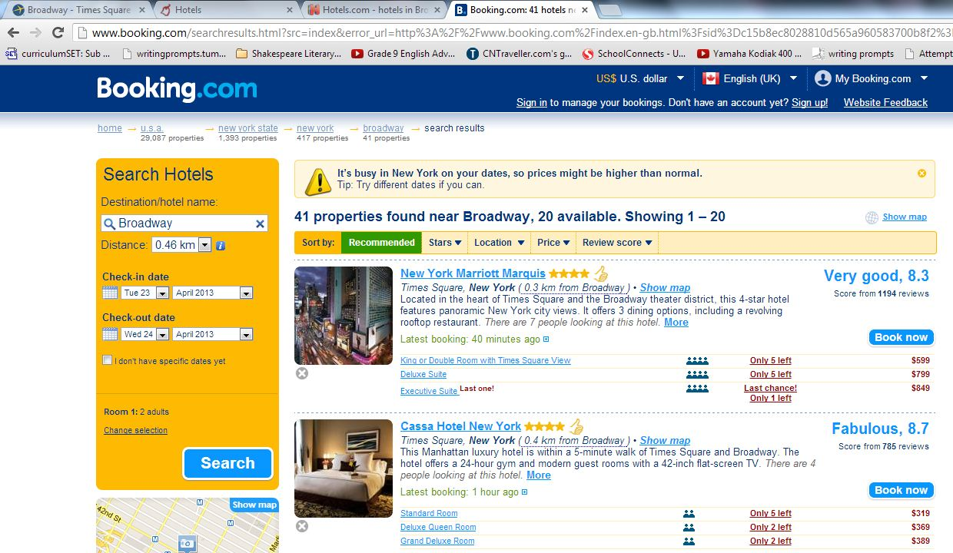
- Search for the exact same thing. (Dates of stay, City, and Landmark if possible)
  - New York Broadway
- On each website, look for the same names. Once you find a hotel on all 4 pages (the exact same hotel), write down the hotel name, and the price. Circle the price that wins.
Hotel Name ↓ | RedTag.ca Price↓ | Expedia Price↓ | Booking.com Price↓ | Hotels.com Price ↓
The New Yorker hotel | $239

