Ancient Medieval History – Social Studies 10 Name: ______________________

Mesopotamia and Egypt Test
PART 1: Mesopotamian Multiple Choice
- ____________ is the belief in one god, instead of many.
  - Polytheism
  - Monarchy
  - Deism
  - Monotheism
- A _________ is a Mesopotamian stepped tower or temple.
  - Pyramid
  - Ziggurat
  - Stele
  - Papyrus
- Which statement best reflects the code of Hammurabi?
  - Women and men are equal
  - Judges are above the law
  - Demand an eye for an eye
  - Let the buyer beware
- What is Hammurabi known for?
  - Building the first pyramids
  - Setting up the first empire in history
  - Creating a code of laws
  - Developing irrigation ditches
- In what form of government is ruling power passed from father to son?
  - Theocracy
  - Hereditary Monarchy
  - Bureaucracy
  - Dynasty
Part 2: Short Answer
Read the following Mesopotamian poem:
“The rampant flood which no man can oppose,
Which shakes the heavens and causes earth to tremble,
In an appalling blanket folds mother and child,
And drowns the harvest in its time of ripeness.”
- How does this poem represent Mesopotamians’ attitude toward nature and religion?
________________________________________________________________________________________________________________________________________________________________________________________________________________________________________________________________________________________________________________________________________________________________________________________________________________________________________________________________________________________________________________________________________________________________________________________________________________________________________________________________________________________________________________________________________________________________________________________________________________________________________________________________________________________________________________________________________________________________________________________________________________________________________________________________________________________________________________________________________________________________________________________________________________________________________________________________________________________________________________________________________________________________________________________________________________

“If anyone is committing a robbery and is caught, then he shall be put to death.
If a son strike his father, his hands shall be hewn off.
If a man knock out the teeth of his equal, his teeth shall be knocked out.
If a man has destroyed the eye of a man of the gentleman class, they shall destroy his eye .... If he has destroyed the eye of a commoner ... he shall pay one mina of silver. If he has destroyed the eye of a gentleman's slave ... he shall pay half the slave's price”
- Hammurabi’s Code
- Using the section of Hammurabi’s Code, found above, tell me if all people were seen as equal in Hammurabi’s Babylonian Empire. Quote laws from the text above to prove your point.
____________________________________________________________________________________________________________________________________________________________________________________________________________________________________________________________________________________________________________________________________________________________________________________________________________________________________________________________________________________________________________________________________________________________________________________________________________________________________________________________________________________________________________________________________________________________________________________________________________________________________________________________________________________________________________________________________________________________________________________________________________________________________________________________________________________________________________________________________
- Give one example from Mesopotamia and one example from Egypt (1 each) of a scientific or technological contribution to modern civilization.
________________________________________________________________________________________________________________________________________________________________________________________________________________________________________________________________________________________________________________________________________________________________________________________________________________________________________________________________________________________________________________________________________________________________________________________________________________________________________________

- Why did the Egyptians mummify their dead? What does this tell us about their religious beliefs? What was the process?
__________________________________________________________________________________________________________________________________________________________________________________________________________________________________________________________________________________________________________________________________________________________________________________________________________________________________________________________________________________________________________________________________________________________________

- What was the Silk Road and what did it do for the economies, and technologies of early civilization?
__________________________________________________________________________________________________________________________________________________________________________________________________________________________________________________________________________________________________________________________________________________________________________________________________________________________________________________________________________________________________________________________________________________________________________________________________________________________________________________________________________________________________________________________________________________________________

- How does writing contribute to the development of a civilization?
____________________________________________________________________________________________________________________________________________________________________________________________________________________________________________________________________________________________________________________________________________________________________________________________________________________________________________________________________________________________________________________________________________________________________________________________________________________________________________________________________________________________________________________________________________________________________________________________________________
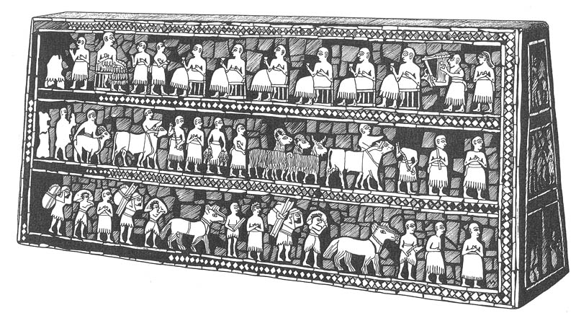
- The Standard of Ur, pictured above tells us a lot about Mesopotamian society. Using your anthropologist skills, what can you tell about Mesopotamian social structure and daily life? (Worth 9)
________________________________________________________________________________________________________________________________________________________________________________________________________________________________________________________________________________________________________________________________________________________________________________________________________________________________________________________________________________________________________________________________________________________________________________________________________________________________________________________________________________________________________________________________________________________________________________________________________________________________________________________________________________________________________________________________________________________________________________________________________________________________________________________________________________________________________________________________________________________________________________________________________________________________________________________________________________________________________________________________________________________________________________________________________________________________________________________________________________________________________________________________________________________________________________________________________________________

- What was the significance of Queen Hatshepsut’s Rule? How was her rule difficult for the Egyptian concept of religion? How does her story help us understand Egyptian government?
______________________________________________________________________________________________________________________________________________________________________________________________________________________________________________________________________________________________________________________________________________________________________________________________________________________________________________________________________________________________________________________________________________________________________________________________________________________________________________________________________________________________________________________________________________________________________________________________________________________________________________________________________________________________________________________________________________________________________________________________________________________________________________________________________________________________________________________________________________________________________________________________________________________________________________________________________________________________________________________________________________________________________________

- What was social structure of Egypt?

- Why was the Rosetta Stone important?
______________________________________________________________________________________________________________________________________________________________________________________________________________________________________________________

- BONUS QUESTION: Write our current year using the Egyptian numerical system.

___________________________________

