Introduction
After the fall of the Roman Empire in the 5th century AD, Europe entered into the Medieval Period (or Middle Ages). Feudalism was the rule of the land.
The Feudal System: Social Hierarchy Breakdown:
​The KingThe king was in complete control under the feudal system. He owned all the land in the country and decided to whom he would lease land. Therefore, he only allowed those men he could trust to lease land from him. However, before they were given any land, they had to swear an oath to remain faithful to the king at all times. The men who leased land from the king were known as barons; they were wealthy, powerful and had complete control of the land they leased from the king.
Barons (Lords or Nobles)The land that barons leased from the king was known as a manor and the barons were known as the lord of the manor. The barons were in complete control of this land. They established their own system of justice, minted their own money, and set their own taxes. In return for the land they had been given by the king, the barons had to serve on the royal council, pay rent and provide the king with knights for military service when he demanded it. They also had to provide lodging and food for the king and his court when they traveled around the country. The barons kept as much of their land as they wished for their own use and divided the rest among their knights.
KnightsKnights were given land by a baron in return for military service when demanded by the king. They also had to protect the baron and his family—as well as the manor—from attack. The knights kept as much of the land as they wished for their own personal use and distributed the rest to peasants. Although not as rich as the barons, knights were quite wealthy.
Peasants (Villeins or Serfs)Peasants, sometimes known as villeins or serfs, farmed land given to them by the knights. They had to provide the knight with free labour, food and service whenever it was demanded. Peasants had no rights. They were not allowed to leave the manor and had to ask their lord's permission before they could marry. Peasants were poor and generally miserable, with no education, political rights or few privileges. They were, however, essential to the success of the feudal system: they worked the land and provided the labour on which the wealth of the estate or fief was based. Without their contribution, the economic system would have collapsed.

In Summary:
The feudal system kept poor people down, and it kept power in the hands of the Church and Kings of Europe.
In the 1700s, the system faced challenges from scientific advances and influential thinkers. The scientific advances (like the view of a heliocentric universe) challenged the position of the Roman Catholic Church. If you challenge the Church, then you challenge the kings (they take their right to rule from the church's authority).

The Monarchy
Kings in many countries came under pressure to reform the way they ruled. Enlightened Monarchy. The concept of ruling wisely, for the people was a move in the right direction.
In France this didn't happen. The people were poor. They were starving. Louis the XVI was living a rich life, while his people starved.

The century from 1750 to 1850 saw the end of traditional European society and its transformation into a modern civilization. Two important historical events dramatically changed the political, economic and cultural landscape of Europe: the French Revolution and the Industrial Revolution.
​
THE FRENCH REVOLUTION

The Notes
The French Revolution was basically a war between the king of France and his supporters, and the people of France. From 1789 to 1799, King Louis XVI (16th) was violently overthrown, removed from power and replaced with a government elected by the people. He was eventually executed for treason.
​
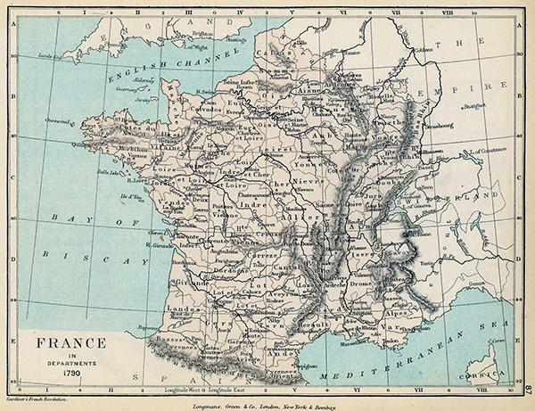

Why study it? Is it significant?
It was a first. A king was overthrown and replaced with a democratic government because people believed they were entitled to rights, freedoms and a government that represented them. It started a chain reaction that led to democratic governments throughout Europe and the Western world in the 19th and 20th centuries.

The French Revolution also affected people everywhere who were living under governments that restricted their freedoms. It inspired them to take action against these conditions. It inspired the anti-slavery movement (because, how can slavery exist if all men are equal?), the movement to win rights and votes for women, and even modern-day freedom movements. The laws, ideas, and role of government developed in France during the early phase of the revolution still inspire people who are oppressed today.
The revolutionaries' first constitution--The Declaration of the Rights of Man and the Citizen from 1789—is still one of the finest examples of democratic principles and ideas that a government could have. Many democratic countries have copied its ideas and wording outright!
We can also learn lessons from the violence and bloodshed of the dark side of the revolution. How much violence is acceptable to attain democratic goals? Should freedoms and rights be limited to protect a government?

Historians examine the following four factors, or causes, to understand why revolutions occur. You will examine these four factors as they relate to the causes of the French Revolution.
New Ideas - New ideas represent and lead to changes in how people view the world and their place in it. New ideas can come from people, inventions, development of technology, etc. New ideas lead people to re-examine society and their role in it, and often to desire change accordingly.
- Philosophers such as Hobbes, Locke, Voltaire, Rousseau inspired people to think and to question what was happening.
While new ideas alone would not lead to revolution, the ideas that these philosophers developed and shared with the public would play an important part.

Social Conflict - Various groups in society disagree with one another, which leads to conflict. Disagreements can be based on religion, language, class, gender, relationships between generations, changing roles for men and women, changes in the family structure, etc.
Economic Conditions - People's standard of living can influence a desire for change? If they are poor, hungry or jobless, people are more likely to want change. A high standard of living means the people have access to better education, information and goods and services, which can also cause change.
Political Factors - What type of government does a society have? Do laws need to change to reflect that society? Does the government represent all the people, or are some left out? Are the laws fair to everyone?

Rights and Freedoms
Practice your historical thinking by discussing how our concept of rights has changed or remained the same (continuity and change) over time by focusing on how you and your peers see rights in your own environment: the school.

- How do the rights that the Enlightenment Philosophers promoted affect life within your school environment? Give some examples.
- How do students' expectations of rights—or the rights that they focus on—differ from those of citizens at the time of the French Revolution? Give examples. Why might they differ?
- How do the rights of individual students compare with the rights of the school to maintain a safe environment?
- How should rights change in your school? Why? For example, are student rights respected or ignored by locker searches, restrictions on cell phone use, security cameras, dress codes, nutrition policies or random searches by narcotics dogs? Why or why not? What expectation of privacy should exist in public schools?

Key Events of the Revolution
Events that happened during the ten years of the French Revolution were numerous and complex. Once the king was removed from power, violence and disorder escalated. While some improvements were accomplished at first—increased rights and freedoms, voting, and a more equitable approach to representation in government—there were also some terrible times. From 1793 onwards, the common people were in charge, and they completely changed France.
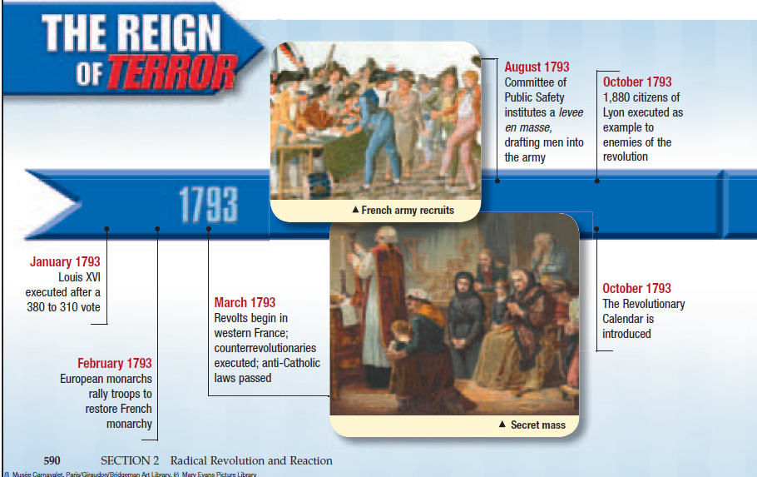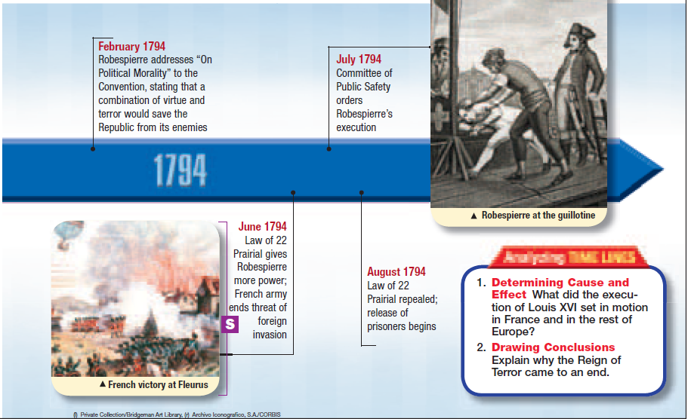

Hobbes
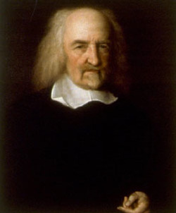
Thomas Hobbes (1588-–1679) saw people as naturally cruel, greedy and selfish. Hobbes believed in a social contract in which people give power to the government in return for an organized society. In his model, government needed to be powerful to ensure order.

Locke
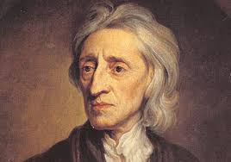
John Locke (1632-–1704) believed that people were basically reasonable and therefore had natural rights—life, liberty and property—and that government existed to protect these rights. Locke proposed that government also had a responsibility to its citizens and could be overthrown if it violated the rights of its citizens.

Montesquieu
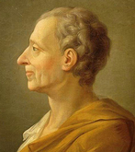
Montesquieu (1689–-1755) studied governments and how they worked (or did not work). He believed that a government needed three branches (legislative, executive and judicial). The various functions and powers of the government should be divided between all three (separation of powers) and each branch should serve as a check on the other two (checks and balances). To see a nation based on Montesquieu's ideas, look at our own Canadian government!

Rousseau
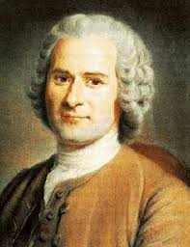

Rousseau (1712-–1778) believed that people were naturally good, but that they were corrupted by the evils of society, especially the unequal distribution of property. He also proposed a social contract in which a freely elected government would place some, but minimal, control over people. He believed people should follow the "general will" for true liberty and look at the good of the community over individual interests.

Voltaire:Voltaire (1694–-1778)—the most famous of the Enlightenment Philosophers—battled corruption, injustice and inequality and defended freedom of speech. His outspoken nature offended both the French government and the Catholic Church—the two traditional powers of France.

Rights and Revolution
Before the French Revolution, political power in Europe was based on the belief that monarchs ruled by divine right: by the power given them by God. With the encouragement of les philosophes, people began to realize that the right of the monarch to govern came not so much from God, but from the people themselves.

This growing recognition of their rights caused the people of France to seek government reform, and to question the way things had always been done.

Responsibility from Rights
\ Enlightenment Philosophers also cautioned that some restriction of rights was necessary to maintain social order. They believed that government must hold at least a minimal amount of control.

This meant that if people wanted the power to choose their leaders. And if they wanted rights, then they also had responsibilities.

Discussion Questions
- How do the rights that the Enlightenment Philosophers promoted, affect life within your school environment? Give some examples.
- How do students' expectations of rights—or the rights that they focus on—differ from those of citizens at the time of the French Revolution? Give examples. Why might they differ?
- How do the rights of individual students compare with the rights of the school to maintain a safe environment?
- How should rights change in your school? Why? For example, are student rights respected or ignored by locker searches, restrictions on cell phone use, security cameras, dress codes, nutrition policies or random searches by narcotics dogs? Why or why not? What expectation of privacy should exist in public schools?

Causes of Revolution: Social Conflict
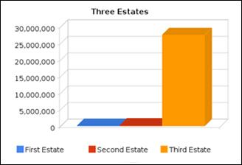

France's population was divided into three social classes, known as the three estates:
- The First Estate: – members of the Clergy (population 130,000)
- The Second Estate: – members of the Noblity (population 350,000)
- The Third Estate: – everyone else, including peasants, farmers, craftsmen, lawyers, doctors and wealthy merchants (population 27,250,000)
The estates didn't see eye to eye on how their country should be run. Most of this conflict revolved around feudal privileges, land ownership and taxation exemptions.

The First Estate - The Clergy (1.5% of the population)The Clergy were both powerful and wealthy. The Catholic Church owned approximately 10% of the land in France and was exempt from taxation.
The power of the Church was under scrutiny from Enlightenment thinkers who called it corrupt and accused it of passing on superstitions. As time passed, a growing number of people agreed.
​
The Second Estate - The Noble (0.5% of the population)The First Estate was made up of members of the nobility and royalty. Their power and wealth came from feudal privileges, an idea left over from the Middle Ages. Due to birthright, all the best jobs and positions in society were reserved for members of the nobility and clergy. This right was passed down through the eldest sons of each family.

Conflict:
The nobles were the ruling class and maintained their power through the feudal system, which made it impossible for someone outside the system to move up the social ladder, despite their intelligence or capabilities. Nobility were able to tax the peasants who lived on their estates, and were also largely exempt from taxation.

The Third Estate – Everyone Else (98% of the population) This estate ranged from poor street people living in cities, to peasantsliving on estates, to landowning farmers in the French countryside, to wealthy, educated merchants.

Although they were a diverse group, they were united in their resentment. They lacked access to the power structures of society, as all the best positions were reserved by feudal privileges. Though powerless, they paid the vast majority of taxes.

The leaders of the Third Estate were known as the bourgeoisie, or middle class. They were urban, often wealthy and educated, but extremely angry because they were limited socially.

Throughout the countryside, feudalism caused problems for peasants who were the legal property of their landlords. Their mobility was restricted, they were largely prohibited from owning land, they paid very high taxes and they had very little freedom.

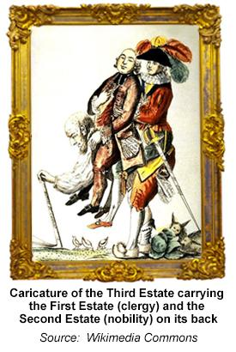

Taxation Crisis: Because of debt from war. Seven Years and American War of Independence
Beginning in the 1750s, France was facing enormous financial problems, which bankrupted the country and increased the overall tensions in the country.

The taxation system of France: inefficient / unfair.
The government of France hired tax collectors. often corrupt. overcharged peasants 4 own profit.
As much as 70% of a peasant income as taxes.
Voluntary taxes for the nobility (pay if you want)
Tax exemption for the clergy heightened social tensions.

Spending on the French and Indian War (1754 to 1763)This war was between British and French colonies in North America. The parent countries—France and Great Britain—supported their colonies with military units and supplies.
Supporting the American Revolution (1776)France supported the Americans' break from Great Britain with troops and money.
Crop FailuresMassive crop failures led to a severe shortage of food and skyrocketing grain prices. Starvation on the streets of Paris was common.
Spending Habits of the RoyaltyIn the years prior to the revolution, the spending habits of the king, and especially his queen, Marie Antoinette, came under attack. She was nicknamed Madame Déficit for her public image of wasteful spending on clothing, jewels, houses, shoes, etc. Although this was more political propaganda than reality, these criticisms played a role in the public's perception of the monarchs as uncaring and financially irresponsible.

Proudly powered by Weebly

Failure of the Monarch
King Louis XVI has generally been described by historians as an ineffective and weak leader. He relied too much on the opinions of his advisors and would do whatever it took to win the favour of the nobility. To make matters worse, his wife, Marie Antoinette, became very unpopular due to her Austrian heritage and her lavish spending habits.
For example, the king hired Jacques Necker to fix the taxation crisis and make the taxation system more fair. Necker pointed out that the Third Estate paid more than their fair share and recommended taxing the nobles and clergy. Fearing that he would lose the support of the First and Second Estates if he taxed them, Louis fired Necker instead. When word of this reached Paris, the Necker Affair, as it became known, became the tipping point that started the revolution.
Failure of France's Traditional Form of GovernmentIn times of crisis (generally financial problems), the king could call a meeting of the Estates General: the traditional assembly of mostly elected representatives from the three estates who would advise the king and approve taxation. Each estate would send representatives to meet in Paris and work with the king (and sometimes against the king) to solve the problem. They would also arrive with lists of their hopes and complaints—called cahiers—to be considered as new laws and decisions were made The Estates General had not met for almost 200 years prior to the French Revolution.
Necker invited the members of the Estates General to submit cahiers expressing their concerns. This unleashed a surge of public criticism against the monarchy, as people voiced concerns fuelled by Enlightenment writings. The most famous was written by Abbe Sieyes, a member of the clergy and an Enlightenment scholar. His famous pamphlet, What is the Third Estate? includes three short statements that summed up the mood of the Third Estate.
