Essays – MLA format

- This is the #1 statement I hear from students: “I don’t need to source, I changed it into my own words.” (Unknown)
  - You are WRONG!
This is call PARAPHRASING – express[ing] the meaning of (the writer or speaker or something written or spoken) using different words, especially to achieve greater clarity. (Collins English Dictionary)
Notice that I paraphrased my definition from this: : “A restatement of the text or passage giving the meaning in another form, as for clearness; rewording.” (Collins English Dictionary)
Notice that I have cited this source twice.
HOW?
Step 1: Either paraphrase or quote the text. Remember to begin and end with quotation marks if you are quoting.
Step 2: At the end of your quote, click the references button at the top of Microsoft word. Look for a drop down menu and make sure it is set to MLA, not APA or any other format for citation. 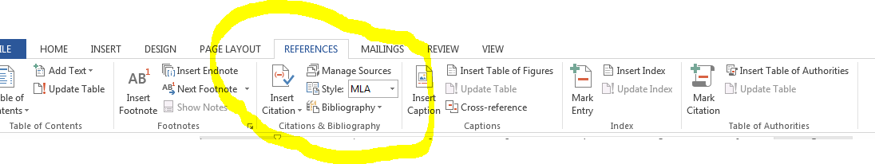
Step 3: In the middle of the menu, just under the references tab, you will see a button that says “Insert Citation”, click it. Then select the format of the work you are sourcing: Book, Website, Journal Article, or Article in a Periodical (magazine). These will be the most commonly used sources.
Step 4: Fill in all fields. (Or as many as possible) NOTE: You may make mistakes here. Check with your teacher if you are unsure, or can’t find the information you need for all the fields.
Field: A blank area in a form that requires input of information.
Step 5: You are done, and can even use this to create your works cited. There is a button for that too. It may be set to Bibliography… you will need to change it to Works Cited.
