Introduction
As Allied forces rolled across Eastern and Western Europe and into Germany, they liberated concentration and extermination camps, revealing the full horrors of Nazi racial policies. Of the millions who had been deported to these camps, the starving and sickly survivors bore heart-wrenching witness to the attempted extermination of European Jews. What the Nazis called the Final Solution to "the Jewish Question" is now referred to as the Holocaust.
A new term, crimes against humanity, came into common use as the Final Solution was revealed to the world. The horror was so great that people required a powerful word— to express the depth of evil it represented; "holocaust—" was such a word. The Holocaust could only be viewed as an assault on the whole of the human race, and therefore a crime against humanity.
Terminology
Anti-SemitismDuring your study of Hitler's totalitarian regime (in the previous module), you saw the term anti-Semitism. Anti-Semitism refers to hostility towards or discrimination against Jewish people. This hostility grew to unimaginable proportions in Hitler's Nazi Germany, and led to genocide.
GenocideIn its online Holocaust Encyclopaedia, the United States Holocaust Memorial Museum describes genocide in these words:
The term "genocide" did not exist before 1944. It is a very specific term, referring to violent crimes committed against groups with the intent to destroy the existence of the group.Click here to visit the source of this quote and to read more about genocide.
The HolocaustWe use the capitalized term Holocaust to refer to the systemic, state-sponsored persecution and annihilation of European Jews by the Nazis and their collaborators between 1933 and 1945. The Holocaust forced a fundamental reconsideration of people's capacity for inhumanity.
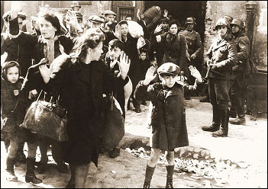
Captured Jews during the Warsaw Ghetto uprising Photo from a report to Heinrich Himmler, May 1943 Source: Wikimedia Commons
The HolocaustThe Holocaust was the systematic murder of approximately 6,000,000 Jews. It was intended to kill every Jew under Nazi rule. Other groups were also targeted for death, including the Roma and Sinti (Gypsies), people with disabilities, and homosexuals. None of these groups were selected for total annihilation as the Jews were. In the name of racial purity and the struggle of the "master race," the Nazis sought to exterminate the Jews from the face of the earth.
How could such inhumanity take place? For those who had listened to Hitler in the beginning, the answer was quite clear. Nazi ideas were based on race. Simply put, what Hitler referred to as the Aryan master race—of whom he considered Germans the best example—was responsible for all the good in the world. Jews were considered the opposite.
In Hitler's terms, Jews were viewed as destroyers of culture and the worst enemies of the master race. Hitler blamed them for conspiring to control the world, through alleged control of international finance, which he believed had hampered Germany in the 1920s and 1930s. Hitler also claimed the Jews were behind world communism, which threatened the German way of life with revolution. That communism and capitalism were opposites (opposing ideas), and enemies, seems never to have entered Hitler's mind. In Hitler's view, the threat was enough to justify the Final Solution and the creation of the death camps.
Holocaust historians have divided the Holocaust and the events leading up to it into different stages. Keep in mind that historians identified these stages after the event, and that the divisions are arbitrary—some historians have identifies three stages, others only two, and some even six or more stages. What the stages do, no matter how they are divided, is help us understand that the Holocaust was a progression, and that the actions taken against the Jewish people grew increasingly violent and intent on genocide.
For our purposes, we will use a four-phase model of the Holocaust proposed by historian Raul Hilberg.
Identification/Definition
First, the Nazi's had to identify who was a Jew, which they considered to be a racial, not a religious, identity. The Nazis passed laws that identified people as Jews based on how many of a person's grandparents were Jewish. Once identified as a Jew, that identity was marked on the person's passport. After 1941, people who were identified as Jews were forced to wear a cloth Star of David on their clothing at all times.
Economic Discrimination and Separation
Jewish people were no longer allowed to work for or employ Germans. Shares in business were taken away and they were no longer allowed to sit on the board of a business (even their own). Many businesses were sold (under duress) to an Aryan and many Jews could no longer practice their professions. Life under the Nazis became more and more difficult for the Jewish people.
Concentration
Once the Jewish people were economically and socially segregated (separated) from society, it became easier for the Nazis to physically separate them as well. Some Jews were forced to move to ghettos; others were sent to forced-labour camps or concentration camps. In all of these circumstances, the Nazis controlled the food, work and every aspect of the lives of the Jews. The Jewish people were now defenseless; without money, food or resources; and cut off from society.
Extermination
In 1942, the Nazis met at the Wannsee conference to discuss how to remove the Jews from German living space and society more quickly and efficiently. After this, the Nazi extermination efforts increased, with mass shootings, mobile gas chambers and deportation to the death camps.
Often, we hear the statistic that approximately 6 million people were killed in the Holocaust, but to understand that statistic, we must be aware that:
- the number 6 million represents a vast number of people—more than we can easily imagine. One way to think of this number of people is to realize that it roughly equals the entire population—adults, children and infants—of New Brunswick, Nova Scotia, Prince Edward Island, Newfoundland and Labrador, and Alberta.
- the number 6 million applies specifically to the Jewish victims. The Jews were the target of the largest, most brutal and concentrated Nazi atrocities, but we must remember that the Nazis treated all people they saw as inferior or non-Aryan in similar ways. The Nazis subjected groups including Roma people (once called "Gypsies"), homosexuals, people with disabilities, Serbs, Poles, Russians, and prisoners of war to imprisonment, starvation, forced labour, mass execution and other forms of abuse. The actual number of European citizens exterminated by the Nazis is much higher than 6 million!
- the number 6 million is composed of 6 million individuals. Every single victim of the Holocaust had a name, a family, a story, and a future that ended too soon in death. To understand the meaning of 6 million victims, learn about some of these individuals, and then imagine 6 million such stories that all ended too soon.
The Death CampsJews were singled out for persecution by the Nazis throughout the 1930s, and the Final Solution policy was implemented from 1941. With the goal of exterminating European Jews, the Nazis set up extermination camps at major rail hubs. They then used the well-developed European rail network to quickly move large numbers of Jews to the camps. Other camps, built to hold the Nazis' non-Jewish victims, also served as collection points and transportation centres to move Jews to the death camps.
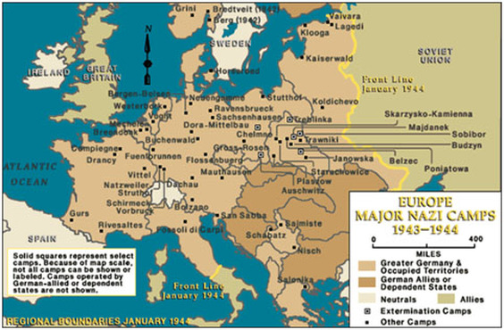
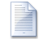
what_makes_good_people_do_bad_things.docx
Download File

Discussion Forum Activity
- Is there an explanation for how and why the people of Germany could tolerate genocide and even help to operate the death camps?
- Read Melissa Dittmann's Monitor on Psychology article, What makes good people do bad things? Then, consider Zimbardo's argument that, in certain situations, anyone can cross the line between good and evil. Do you agree? Why or why not?
Write a response to be handed in.
International Response
​Decades after the Holocaust, historians continue to question whether a different international response could have saved at least some of the millions of victims of the Holocaust. Critics say that had the Allied governments intervened, they could have saved many victims. Others say that the Allies had very little information as to the location or purpose of the death camps or, at the very least, the details of buildings within the camps that would have allowed for precision bombing.
The other criticism of many nations was their refusal to accept Jewish refugees attempting to leave Germany. Immigration quotas, and many countries' outright refusal to accept many Jewish refugees, left the refugees with little choice but to leave Europe. Some countries, like Sweden, accepted Jewish refugees, which helped Denmark save most of its Jewish population and Norway about half if its Jewish population. These countries also accepted survivors after the war for medical treatment. Unfortunately, they were the exception and not the rule. Other countries, including Canada and the United States, accepted very few.
​
Genocide did not begin, nor end, with the Holocaust. While the international community cried out after the horrors of the Holocaust that "never again" would such atrocities be allowed to happen, that promise has not been kept.

