Curriculum Overview and Suggested Time Lines
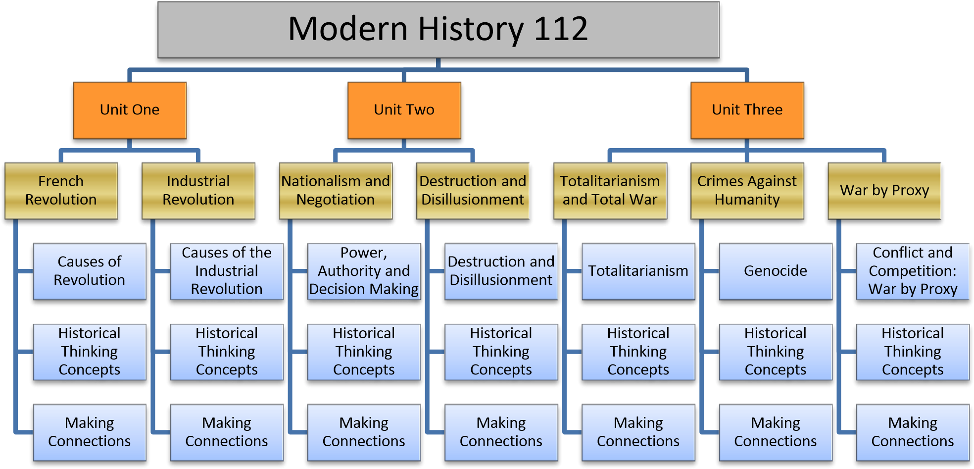
This timeline is offered only as a guide as to how outcomes may be covered in one semester:

Week 1:  - Course Introduction  - Introduction to History  - Causes of Revolution  * | Week 6:  - Workers‘ Rights  - Workers‘ Rights  - Connect the Ind Rev 4. Connect the Ind Rev  5. Connect the Ind Rev | Week 11:  - Treaty of Versailles  - Connecting the Treaty  - Connecting the Treaty  - Ideology: Fascism | Week 16:  - Berlin Blockade  - Nuclear Threat  - Cuban Missile Crisis  - McCarthyism
Week 2:  - Enlightenment  - Enlightenment  - Social Conflict in France  - Social Conflict in France  - Government in France | Week 7:  - Power Relationships  - Power relationships  - Exercise of Power  * | Week 12:  - Ideology: Communism  - Rise of Totalitarianism 3. Rise of Totalitarianism  - Rise of Totalitarianism  - Effects of Totalitarianism | Week 17:  Note: Please work these days into the schedule (as required to represent topics, assessment, exam review etc.)*
Week 3:  - Economic Conditions  - Economic Conditions  - Course of the Revolution  - HT Concept Significance  - Assess the Revolution | Week 8:  - Power Potential  - Historical Perspectives  - Historical Perspectives  * | Week 13:  - Total War  - Causes of Second War  - Causes of Second War  - HT Concept Cause & Consequence | Week 18:  Note: Please work these days into the schedule (as required to represent topics, assessment, exam review etc.)*
Week 4:  - Connect the Revolution  - Connect the Revolution  - Industrial Revolution Ideas  - Social Conflict & Change | Week 9:  - Modern Nationalism & War  - Modern Nationalism & War  - Industrialized Warfare  - Industrialized Warfare | Week 14:  - Cause & Consequence  - Canada and the War  - Genocide | Week 19:  Exam Week
Week 5:  - Response to Industrialism  - Response to Industrialism  - Economics of Industrialism  - Economics of Industrialism  - HT Concept Cause & Consequence | Week 10:  - Industrialized Warfare  - War & Individuals  - War & Societies  - HT Perspective-Taking  - Treaty of Versailles | Week 15:  - Genocide  - HT Concept Evidence  - HT Concept Evidence 4. Post-War Genocides  5 Cold War & Containment

