Social Studies 9 – Syllabus

Teacher | Jonathan Standring | E-mail | jonathan.standring@nbed.nb.ca
Website/ QR Code | jstandring.weebly.com | Extra Help | - Before school by appointment  - After school by appointment  - At lunch by appointment  - Through my website’s question form 24/7
Room # | 120
Late Assignments

Students cannot turn in assignments which are formative in nature once a summative assessment has been collected. Special circumstances must be discussed in person between the teacher and student.

Students must complete all major assessment components in each of their five courses and be passing all courses in order to request an exam exemption.

Course Description:
In this course students investigate our Canadian identity and its personal significance for them. Within a project based approach appropriate for social studies learning, students investigate the many peoples, identities, histories and the geography that make up our diverse country. Students are exposed to a variety of different media including video and multimedia information.

Assessment Plan:
The Exam is worth 30%.
Major Assignments and Tests are equally weighted for the remaining 70%.

General Classroom Procedures:
Put phones away before the bell.
Food is allowed.
You are to keep the classroom clean.
Put things back as you found them.
Be good human beings.
Our intention should be to make the world better.

Course Outline:
Unit One: EXPLORING CANADIAN IDENTITY
Guiding Question:What art (video, visual, music, written, etc) represents not just you, but all of Canada?
9.1.1 Investigate how artistic and literary expression reflects the following aspects of Canadian identity: landscape, climate, history, people, and related challenges and opportunities.
Activities:
- Mind Map
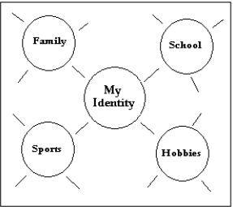
- Features that Identify My Province
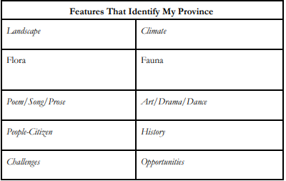
- Analyzing Images of Canada
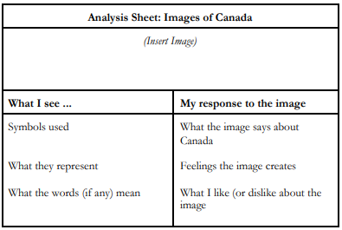
- How to Critique a Cultural Image
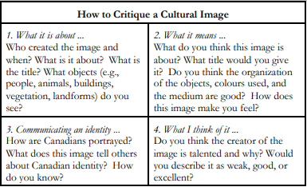
Final Project: Create a physical or digital portfolio of images, literature, video, and music. This portfolio must answer the guiding question:
What art (video, visual, music, written, etc) represents not just you, but all of Canada?
And
Why are these images important? Do they present a particular bias toward, or against a certain group? Support your answer with an explanation of why.

Unit Two: GEOGRAPHIC INFLUENCES
Guiding Question:What is the geography of Canada and how has it shaped our identity in various places? How will it continue to shape us? Why and to where do people migrate?
9.2.1 Demonstrate an understanding of the basic features of Canada’s landscape and climate.
9.2.2 Analyse the effects of selected geographic factors on Canadian identity
9.2.3 Demonstrate an understanding of the nature of migration and its impact on post-1920 Canada
9.2.4 Analyse the effect of geographic features on the development of Canada and of a selected country with similar geographic features.
Issues that may be discussed: topography, climate regions, variations in physical landscape, how geography affects culture, variations in language, regional identities, migration, push and pull factors, refugees, rural decline, urbanization, industrial revolution, site factors, situational factors,
Activities:
- Introductory assumptions (stereotypes) paragraph about why Canadian culture is different in one geographic area than another - for example - Maritimes compared with prairies, west coast, upper Canada (Ontario), or northern Canada. What climatic and geographic features shaped these differences?
- Advantage offered by different site factors
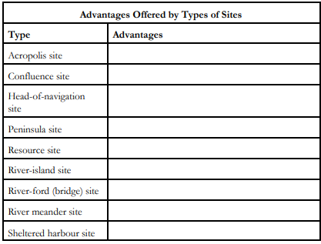
- Explanation for Selected Climate Conditions
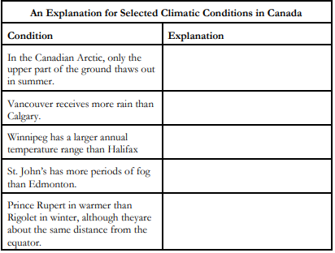

- Paragraph about Canada’s Climate Stereotype: “Canada is a cold, snowy, northerly place.”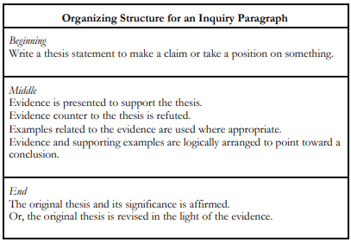
- Where should we establish a community?
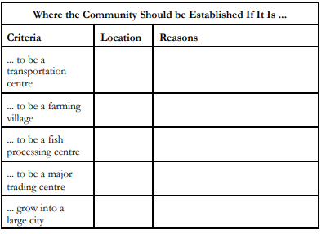
- Urbanization sentence: given the related population data, write a sentence comparing the percentage of Canadians living in towns and cities in the late 1800s with the percentage today.
- Read a newspaper account of the decline of some towns in Canada. Complete the following organizer to determine causes and effects of this trend.
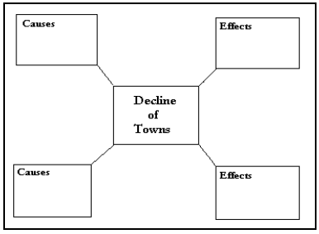
- Divided groups - Describe one region of Canada, to be written into the classroom chart.
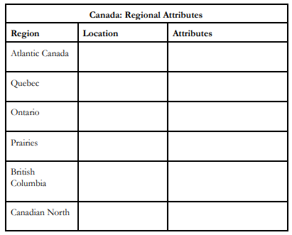
- Why do people migrate?
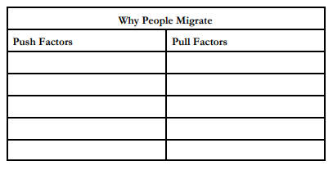
- List, in order of importance, three factors that might cause them to leave Canada. Ask them to share them within a group to see similarities and differences.
- Cite evidence to support the following statements about patterns in immigration to Canada.
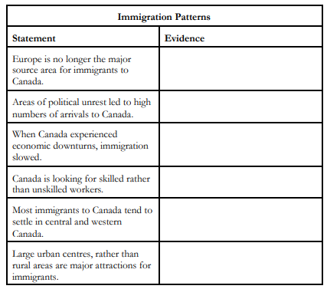
- Complete the following chart to compare location, physical features, and climate of Australia with those of Canada.
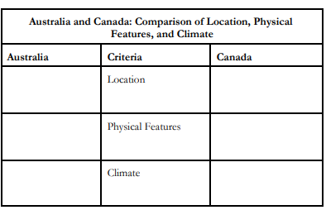
Final Assessment: Using many of the factors listed above, write a paragraph explaining why you would choose to live in a particular place. Remember that climate, physical features, push/pull factors, urban and rural factors, services, and transportation all play a part in your choice.

Unit Three: DECADES OF CHANGE
Guiding Question: How have world events shaped Canadians and our different levels of wealth over time? Think about our rich and poor. Think about wars, the stock market crash, new technologies, and new cultural trends.
9.3.1 Analyse the impact of changing technology and socioeconomic conditions on differing prosperities and lifestyles in Canada in the 1920s and 1930s
9.3.2 Demonstrate an understanding of Canada’s participation in WWII
9.3.3 Analyse the effect of WWII on Canada and her people
9.3.4 Evaluate Canada’s role in the world since WWII
9.3.5 Analyse the impact of changing technology and socioeconomic conditions on Canada’s prosperity and lifestyles in the 1950s and 1960s
9.3.6 Compare the social and cultural trends in Canada in the 1950s, 1960s and 1970s
9.3.7 Analyse how globalization has affected Canada and Canadians since 1980
Issues that may be discussed: prosperity, depression, tariffs, NAFTA, assembly lines, primary and secondary industries, installment plans, credit, haves and have-nots, new technologies, stocks, shares, dividends, interest, public relief, public works, reparations, appeasement, conscript, blitzkrieg, merchant marine, propaganda, convoys, fronts, Canada’s contribution to the war (113), genocide, the war at home, social change, suffrage, rationing, referendum, internment camps (japanese), marginalization, war art, cold war, satellite states, iron curtain, ideologies, communism, capitalism, arms race, collective security, NATO, NORAD, Diefenbunker, Korean demilitarized zone, consumer spending, supply/demand, GDP, social security (1945), regional disparity (p.150), equalization payments, labour-saving devices (p.154), baby boomers, teenagers (p.162), counterculture, hippies, civil rights movement (p.171), women’s movement (p.173), First Nations Issues (p.175/ch.17), peacekeeping, peacemaking, peacebuiliding, terrorism, transnational corporations (globalization), climate change.
Activities:
- 1920s and Economic development
  - work with a partner and identify the causes and characteristics of economic prosperity in Canada from 1924-1929. The following organizer may be used to present the findings.
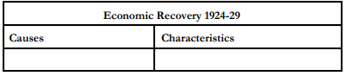
  - Arrive at their own decision on the issue of American investment in Canada. The following organizer may be used.
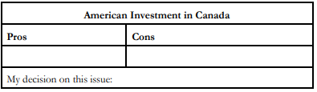
  - Compare the economy of Central Canada, British Columbia and the Prairies with that of the Maritimes during the 1920s.
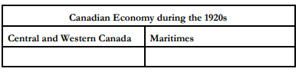
- Create a map of Canada that illustrates “Economic Development in Canada during the 1920s”. Design symbols that represent the major industries that developed during the 1920s and then place these symbols on the appropriate region of the map. Also, include on the map short bubble notes that explain how and why these industries developed in these specific regions.
- Supports statements about economic development
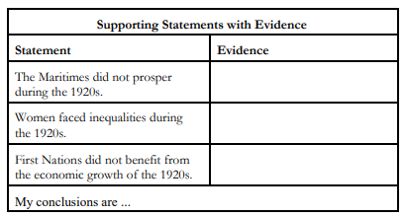
- Impact of inventions: radio, automobile, combine, snowmobile, telephone, air transport, motion pictures. Participate in a jigsaw cooperative learning strategy.
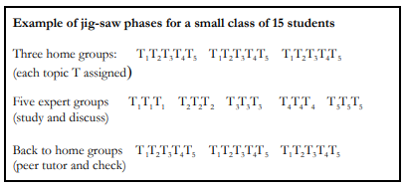
  - All students then complete the chart below..
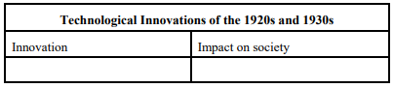
  - Write a paragraph explain the impact of new inventions on family life
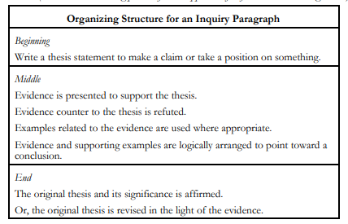

- Use the jigsaw cooperative learning strategy to research the importance of political issues of the 1920s (e.g., the Chanak Affair, the Balfour Declaration, and the King-Byng Affair) to Canadian independence. Each student may then complete the following chart.
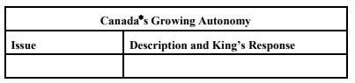
- Develop a mind map illustrating the causes of the depression and then use the information to complete a chart in which they rank the causes in order of importance and justify their ranking. As a class, discuss the results and arrive at a consensus as to the main causes of “The Great Depression.”
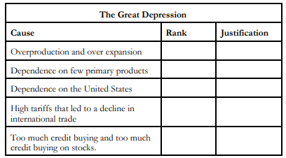
- Assume the role of a person living in different parts of Canada during the 1930s. Roles include a immigrant living in Vancouver, prairie farmer, middle class business person in Toronto, widow living in the city with several children, single unemployed man in rural Quebec, fisher from the Maritimes, First Nations person in Nova Scotia. Then, research and briefly describe some of the social, economic and cultural circumstances of their lives at different times during the decade.
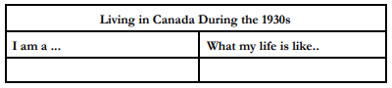
- Use the following organizer to guide their analysis of a letter, diary entries, or songs written about the hard times of the Depression for their historic value. (p.89-90)
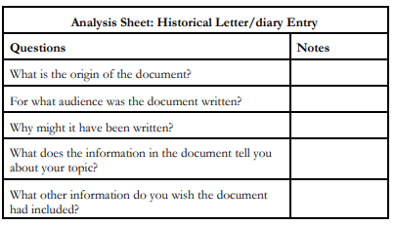
- Major Assessment Piece:
  - create a “Canadiana Through the Decades” exhibition. Each student contributes one item representative of the 1920s or 1930s that they feel is an aspect of Canadian identity. Display items might include photos, posters, advertisements, clothing, magazine covers, artifacts (real or recreated), models, art work, music (tapes), or videos. These could focus on, for example, Canada’s success at the 1928 Olympics, the “Golden Age of Sports for Women” in Canada, an early Hockey Night in Canada broadcast, Mary Pickford’s movie stardom, fashions of the era, or Carr or Group of Seven paintings.

Second World War Section
- Identify from their text and other sources the underlying causes of the Second World War and then complete the following organizer to briefly explain each cause. They should write a main cause and list details to provide an explanation.
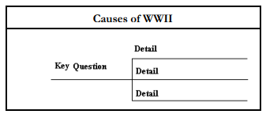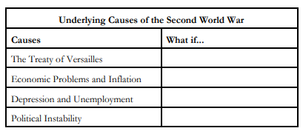
- Use a map of Europe to trace and label Hitler’s acts of aggression -steps to war from 1933-1939. In your opinion, at what point should Hitler have been stopped? Why?
- Create a response to Canada’s Entry into WWII from the perspective of one of the following: : a) a pacifist, b) a French-Canadian nationalist, c) a member of Canada*s armed forces, d) a Jewish Canadian, e) a parent who lost a son in World War I, f) a German Canadian, and g) a Polish or Czechoslovakian Canadian.
- Classify selected statements about the beginning of World War II as either fact or opinion and explain their decision.
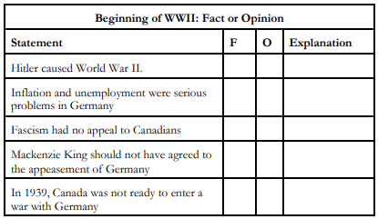
- Use the following organizer to examine key battles and the extent of Canada’s contribution. Draw conclusions about Canada’s military involvement in and contribution to WWII.
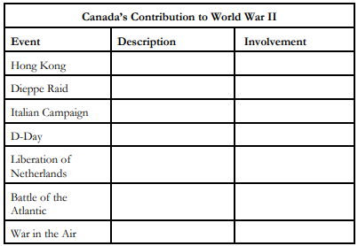
- Examine contributions on the homefront during WWII
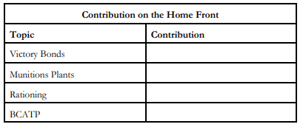
- Examine propaganda posters on p.107. Answer questions 1-4.
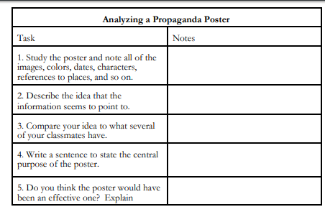
- Research perspectives of people during the Second World War using EBSCOHOST, to create a profile of a person and their experiences.
- “An Eyewitness Account of the Dieppe Raid” (p.109 of textbook)
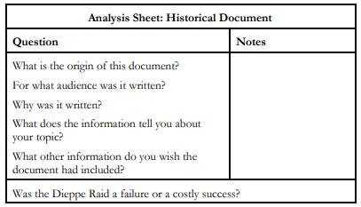
- Prepare an paragraph argument: “World War II was an important step in the Women’s liberation Movement”
- Develop an organizer that shows Canada’s human and material contributions to World War II. Explain how each contribution helped the war effort.
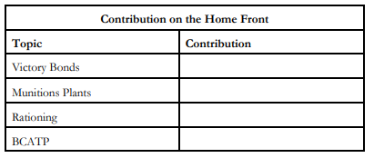
- Use the following statistics to draw a bar graph to show the human cost of war. What percentage of those who went to war never returned?
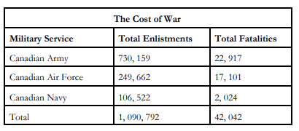
- P.128-31 - Prepare a paragraph discussing the treatment of African Canadians, First Nations people, Japanese Canadians, and Jewish refugees. Discuss the reasons given at the time, the attitudes, and contrast that with the attitudes and beliefs regarding Syrian refugees and their treatment.
- Complete the following chart to record perspectives of what different people might have on the internment of Japanese Canadians during World War II
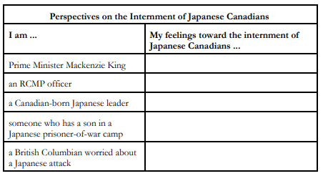

Cold War Section
- Work in groups to research selected events (e.g., the Yalta Conference, the San Francisco Conference, the Gouzenko Affair, Churchill’s “Iron Curtain” speech, Berlin Blockade, NATO, and the Warsaw Pact) following World War II and decide if each event would either encourage peace or encourage a Cold War. Provide an explanation for each classification.
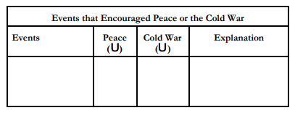
- Reflect upon the Cold War and complete the following chart to decide whether or not they would have supported the stockpiling of weapons of mass destruction.
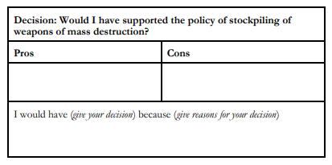
- Compare the origins, membership, and goals of NATO, Warsaw Pact, or NORAD.
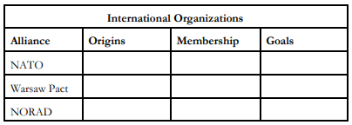
- Complete a chart on the costs and the benefits for Canada of belonging to NATO and NORAD.
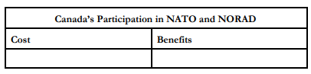
- Research and write a descriptive paragraph to explain Canada’s role in NATO and NORAD.
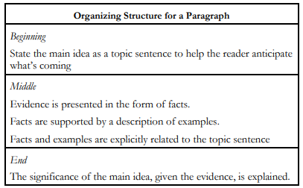
- Complete an organizer to compare Cold War “hot spots” (e.g., Berlin Blockade, Korean War, Suez Crisis, Cuban Missile Crisis).
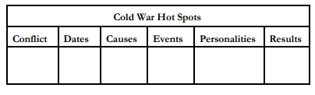
- Use a map to locate, colour, and label the areas where Canadian peacekeeping forces have been sent since 1945. Then, working in groups of three or four, research one of these operations according to the criteria provided in the chart below
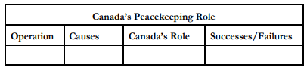
- Create a web diagram to illustrate the effects of the plastics revolution on life in the 1950s and 1960s. Include criteria such as the economy, everyday life, fashions, and world trade. Write a paragraph about the lasting effects today.
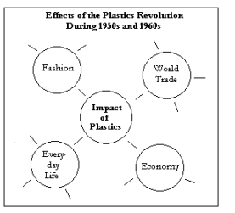
32. Final Assessment Piece:
Find information to compare consumer and political attitudes in the 1930s, 1940s, and 1950s. Then, design and administer a survey to complete a fourth column explaining consumer attitudes today.
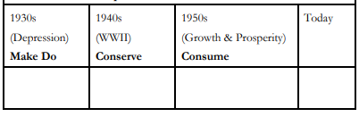
Then write a reflection paragraph where you compare the attitudes and reasons for similarities and differences.

Unit Four: CITIZENSHIP
Guiding Question: What does it mean to be a citizen, and how can we engage with the issues in our country and our world, in a positive, effective way?
9.4.1 Take age-appropriate actions that demonstrate the rights and responsibilities of citizenship (local, national and global)
9.4.2 Demonstrate an understanding of how citizenship has evolved over time
9.4.3 Demonstrate an understanding of the structure and operation of government in Canada under a federal system
Issues that may be discussed: Immigration, Refugee crises, Rights, the Canadian Citizenship test, Canadian Charter of Rights and Freedoms, Universal Declaration of Human Rights, Poverty, Drug Abuse, Unemployment, Education, Forms of Protest, How our government works, Voting, Political Parties, thoughtful discourse, Election Hacking, Social Media Manipulation. Globalization, conservation, activism, consumerism.
- Complete an “Anticipation Guide” on the concept of citizenship. They respond with “agree” or “disagree” to a series of statements about citizenship. Then, in small groups or in pairs students discuss their responses and views.
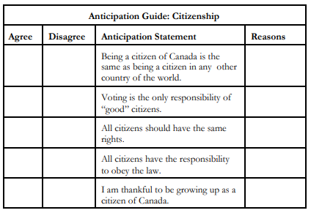
- Use the following chart to investigate the topic of consumerism.
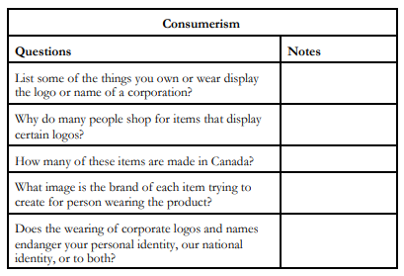
- Assume the role of an advocate for one of the movements (e.g., gender equality, human rights, aboriginal rights) that developed in the 1960s. Prepare a speech to deliver to a protest rally. The following topics may be used or they may develop their own.
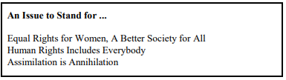
- Research the North American free trade debates of the 1980s and 1990s. Create a chart of arguments for and against free trade. Decide if you would have voted for or against the agreement if you had been able to vote at the time. Then, write a brief paragraph about your position.
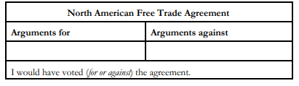
- Find a news article about NAFTA today. Should we pursue NAFTA, another free trade deal with the USA, or nothing at all? Use facts to support your answer.
- Chart the consequences of continued trade with a nation that ignores human rights abuses. Assess and evaluate the consequences of the various choices that may be made by government as identified in the chart below. Then, examine their personal buying patterns, assess the consequences of their decisions and develop a buying pattern action plan
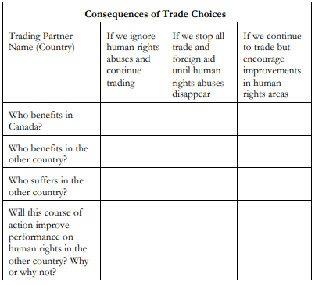
- Debate the following statement: “To me, allowing a mounted policeman to wear a turban is equivalent to allowing someone to change the words of our [national] anthem or fly our flag with a fleur de lis or stars and strips in the corner.” - Journalist Diane Francis. The topic may be expressed as “ Be it resolved that national symbols and practices are a part of Canadian citizenship and should remain unchanged.
  - For a debate evaluation form, refer to Suggestions for Assessment, Outcome 9.3.3, page 103of this curriculum guide.)
- Participate in a think-pair-share cooperative learning structure to examine what the terms rights and responsibilities mean.
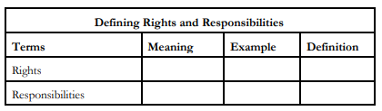
- Brainstorm what they feel are their rights. Create a list of each person’s rights as an individual and then identify the responsibilities associated with each right.
- Assume the role of citizenship judge and prepare a chart to help instruct the participants of a citizenship court on the rights and responsibilities of Canadian citizenship.
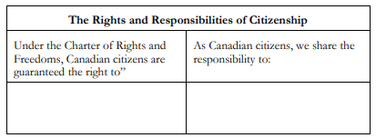
- Explore Canada’s Citizenship and Immigration website to learn about the current criteria for becoming a Canadian citizen.
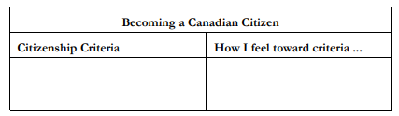
- Take the citizenship test.
- Research another country to compare its citizenship and immigration policies and practices to that of Canada.
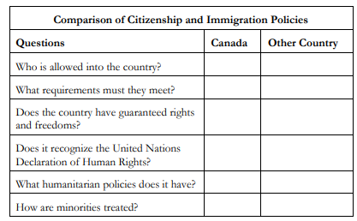
- complete a K-W-L-H chart about the Canadian Charter of Rights and Freedoms or some aspect of the charter, such as, democratic rights, mobility rights, legal rights.
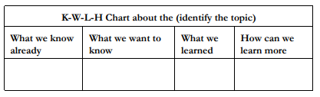
- consider the situation in the table below and identify which of the Canadian Rights and Freedoms applies in each case.
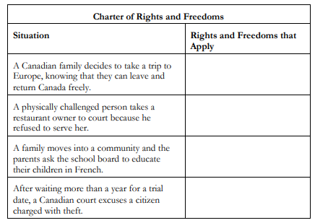
- Write a paragraph to describe how citizens can support the rule of law in their community, province, and country. They may include reference to: support for such initiatives as freedom of information legislation, public legal information programs, and community-police relations programs. As well, they might mention the role of citizens in speaking out against injustice and disadvantaged groups, serving on a jury, and monitoring the effectiveness of the legal system.
- Work in pairs and decide which level of government (municipal, provincial, or federal) would have the power to help them solve each of the following problems or concerns.
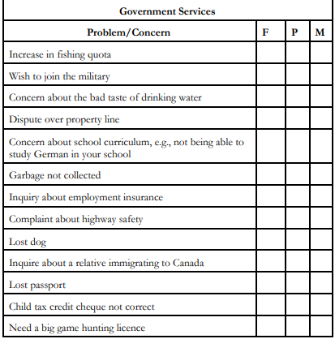
- Collect two articles that feature a person in government. Students are to find out: name of branch of government represented, role in government and why he or she is in the news.
- Construct a flow-chart to illustrate the sequence of events that leads to the formation of governments. Include the following: a) candidates for the various political parties are selected for each electoral district, b) candidates campaign for their election, c) people vote for candidate of choose, d) political party with the most elected representatives becomes the governing party, e) leader of governing party becomes the Prime Minister, and f) Prime Minister chooses the cabinet who runs government departments.
- CBC Vote Compass to see where you stand on the election.
- Research a candidate in the provincial election: What is their platform? What issues are they strongest for/against? Do you find them trustworthy? Do a social media search about them, to see what they have posted and said.
Final Assessment: Active Citizenship Project
- Chaastims story. The little duck can accomplish something great.
As a class or individually.
On a local, national, or global level: Identify an issue. Identify the related need, responsibility, and right. Create a campaign, or take action to help in some way. Document your action and the results of that action through one of many ways: picture, video, journal, podcast, etc.

Unit Five: CHALLENGES AND OPPORTUNITIES
9.5.1 Identify and analyse the economic challenges and opportunities that may affect Canada’s future
9.5.2 Analyse the political challenges and opportunities that may affect Canada’s future
9.5.3 Analyse the social and cultural challenges and opportunities that may affect Canada’s future
Issues that may be discussed: Climate change, refugees, fossil fuels, green energy, forestry, Official Languages Commissioner, NAFTA, free trade, election hacking, social media trolls influencing elections, government service to rural communities, equal representation in government, marijuana legalization.
Activities:
- Look at https://www150.statcan.gc.ca/n1/pub/12-581-x/2018000/pop-eng.htm the StatsCan population.
  - Graph the population of Canada according to the years indicated.
  - Check the data on provincial populations. Which are growing? Which are shrinking?
  - What are some possible reasons for this trend?

Province | Growing / Shrinking? | Reasons?  example: migration, mortality, economic

- Look at https://www150.statcan.gc.ca/t1/tbl1/en/tv.action?pid=1710000501, the population/age demographics and make statements about the following:
  - Which age demographic is growing?
  - Which age demographic is shrinking?
  - What services will the government need to increase in the future? What services will the government need to decrease?
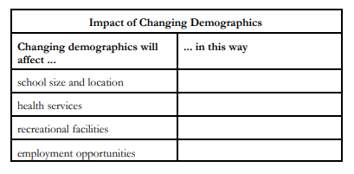
- Use the following chart to record potential threats to a sustainable supply of clean water in Canada.
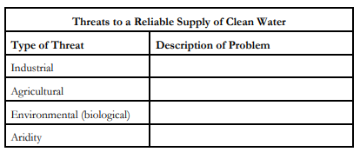
- As water scarcity increases, we need to remember that the ice caps are a source of water. They are north of Canada. What if other nations need water? What may happen? What may we do?
- What is the current debate regarding climate change and energy?

K | W | L | H - how can I learn more

- Find a news article regarding a current energy issue in Canada. Write a summary of the issue.
- What are some issues regarding sustainability of the following energy sources?
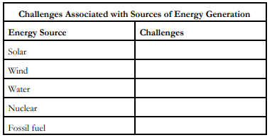
- Listen to a speech by an elder of an Aboriginal organization (e.g., the Assembly of First Nations, Inuit Tapiriit Kanatami, or the Métis National Council) on a specific challenge that his or her group is facing in achieving autonomy and/or self-government. The following organizer may be used to analyse the speech.
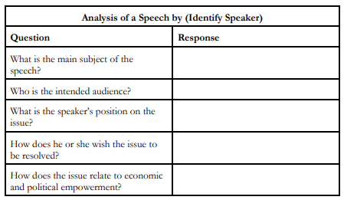
- Watch Secret Path, read, watch, or listen to a news report on the removal on Sir. John A. MacDonald’s statue. What are some issues that face Canada regarding past treatment of First Nations peoples?
https://www.ctvnews.ca/canada/sir-john-a-macdonald-scrubbed-from-scottish-government-websites-1.4065107
https://secretpath.ca/
https://globalnews.ca/video/4383290/city-of-victoria-removers-john-a-macdonald-statue
- How is this similar to the removal of the Robert E. Lee statue? http://fortune.com/2017/08/13/charlottesville-statue-lee-removal/

Similarities | Differences

- What is the Truth and Reconciliation Commission?
http://www.trc.ca/websites/trcinstitution/index.php?p=102
https://newsinteractives.cbc.ca/longform-single/beyond-94?&cta=1
http://www.cbc.ca/player/play/2668683442
- What is our role as Canadian citizens moving forward in addressing issues related to Indigenous peoples? Their prosperity, autonomy, power over natural resources?
- Compare the treatment of First Nations people to that of another oppressed group in history, watch the Racial Wealth Gap Explained on Netflix. Discuss similarities and differences between situations in the USA and Canada.
- What can we do in our own small way?

Final Project: 9.6.1 Portray their personal understanding of Canadian identity
This project is allows for students to create a portfolio of works which represent their complete understanding of what Canadian identity is, based on all previous units.

