Mobilization
​​https://nbvhs.nbed.nb.ca/d2l/le/content/29477/viewContent/1041799/View
​

Great War Maps & Battles

Germany's Schlieffen Enacted
War of Movement - this is important. Take territory quickly with marching troops. Win battles and move.
- Take France before Russia can mobilize.
- Attacked through Belgium.
- The plan failed.

Western Front
Trench warfare: in which opposing armed forces attack, counterattack, and defend from relatively permanent systems of trenches dug into the ground. Trenches are close to each other. They dig in when the superior firepower of the enemies make you “dig in” so and sacrifice mobility in order to gain protection.
- This happened first at the MARNE. Creating the Western Front.
- The Western Front was an area where little movement took place. Trenches were dug, and troops fought over the same few miles from 1914-1918.
Trench Warfare - why not just jump over the trench and take the other side? THEY TRIED THAT! THEY TRIED EVERYTHING YOU WILL THINK OF. THEY WERE INTELLIGENT MEN, TRAINED IN COMBAT.
The new technology of war made it deadly.
​ The war quickly became a war of attrition: an effort to wear down the enemy by destroying more men and equipment.
Tanks and poison gas made their first appearance on the battlefield. New and larger artillery pieces rained death down on the trenches.Machine guns killed advancing infantry on a scale not seen in warfare before. Chlorine gas burned flesh and destroyed eyes and lungs. Zeppelins spied and bombed from above while airplanes battled across the skies in aerial dogfights. On the high seas, dreadnought class battleships made naval warfare so dangerous that the fleets were reluctant to fight each other in traditional battle formations. From under the waves, U-boats attacked naval and merchant supply ships for the first time. This was indeed a new form of war.​

Key Western Front Battles
Ypres
Verdun
Somme
CHECK UNDERSTANDING
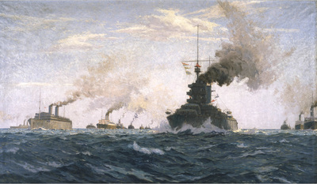
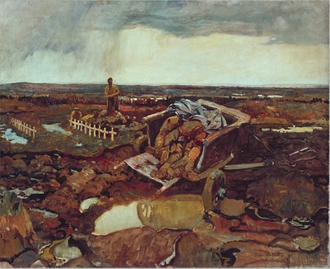
Compare the two pictures on this page: Canada's Answer by Norman Wilkinson and Fred Varley's For What? n the first picture, Canada's troops are headed off to Europe at the beginning of the war. The second painting depicts a person cleaning up a battlefield following a battle near the end of the war. Consider how the perception of the war changed, as reflected by these two pieces of artwork.

Eastern Front
On the Eastern Front, trench warfare was not used and a war of movement continued
After the Communist Revolution of 1917 (part of the Russian Revolution), Russia made a separate peace with the Central Powers.
​

Wars End
In the end, the Central Powers could not win the war of attrition. They did not have the men to reinforce their armies. They did not have the resources to manufacture the weapons and munitions they needed because they could not call on their empires. To do so would have required access to the seas, and the British navy choked off that access.
The Allied powers, on the other hand, could not be defeated because they had access to the resources and manpower of their empires. They were not strangled by blockades as Germany was. Nonetheless, after several years of slaughter on the Western Front, they did not have the strength to win either.
The reluctant entry of America into the war ensured the defeat of the Central Powers.
The United States not a world power yet.
No tradition of involvement in world affairs.
Nonetheless, President Woodrow Wilson led the USA to war in 1917.
The arrival of America's fresh troops and, more importantly, the new resources to make arms and munitions, tipped the balance in favour of the Allies.
But historians say that USA didn't make a difference.

Post-war Concerns
An idealistic US President Wilson made a speech outlining his 14 Points for making peace.
Germany saw this as an offer of peace and Germany sought peace on the basis of the 14 Points, in the belief that they would be treated fairly.
The horrors of the first industrialized war finally came to an end at 11:00 a.m. on November 11, 1918.
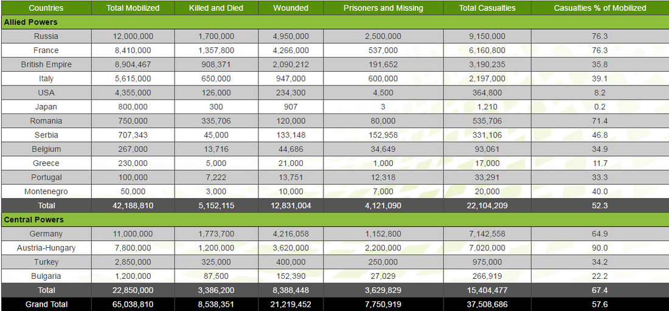
When the fighting ended at 11 a.m. on November 11, 1918, the German people were stunned to find they had lost the war. Government-controlled propaganda had made them think they were winning right up until the very end. The generals, however, had known they were losing the war of attrition.

The Weimar Republic
When their government announced the armistice (an end to the fighting), many Germans thought they must have been betrayed. After all, no fighting had taken place on German soil. The press had announced victory after victory. How could they have lost?
Kaiser Wilhelm II left the throne and went into exile.
A new German republic, called the Weimar Republic, was established under the leadership of socialist President Ebert. The new leaders of Germany were left to rebuild the German economy. They signed what would turn out to be the harsh terms of the Treaty of Versailles.

The Treaty of Versailles
Harsh
Blame-filled
Created the conditions for another war
The key players in the creation of the peace settlement were Britain's Prime Minister Lloyd George, Prime Minister Georges Clemenceau of France, and American President Woodrow Wilson. These were the Big Three.
President Woodrow Wilson had announced his 14 Points as early as January of 1918. They formed his agenda for the peace talks, and included the following goals:
- an end to secret alliances like those before 1914
- arms reductions to reduce the risks of militarism
- national self-determination for all peoples to resolve issues of nationalism and imperialism
- the return of all French territory, including Alsace-Lorraine, to soothe France's long-standing desire for revenge against Germany
- the creation of a League of Nations to protect the peace
Wilson's ideas were regarded as idealistic and unrealistic by many.
Prime Minister ClemenceauFrance's Prime Minister Clemenceau went to the peace talks with more practical demands:
- Return Alsace-Lorraine to France.
- Make Germany so weak that it will never threaten France again.
- Set reparations high enough that Germany will pay for the costs of the war.
Clemenceau's hard-headed agenda was a contrast to Wilson's idealism. The French Prime Minister was one of those who scoffed at what he saw as the impracticality of the 14 Points.
Prime Minister Lloyd GeorgeBritain had been through an election by the time of the peace conference. Many speeches had been made about making Germany pay, but Prime Minister Lloyd George was more moderate in his approach.
- Germany must certainly be made to pay reparations, but not to the extent that they would destroy the German economy. Impoverishing Germany would only be a cause for another war later on.
- Germany should return territories it had captured during the war. It should not lose large parts of its original territory, though, as it would eventually want to fight to recover them.
- Germany's armed forces must be reduced so it would not threaten peace again; however, the terms of the peace should not weaken Germany to the point that it could be taken over by others.
The Treaty of Versailles
When it was finalized, the Treaty of Versailles included terms that addressed reparations, territory, arms limitations, national self-determination and a League of Nations.
Articles 1 to 26 of the treaty set up the League of Nations. It was intended to be a place where differences between nations could be resolved peacefully in order to avoid war.
Articles 27-30 dealt with the German boundaries by restoring Belgium and returning Alsace-Lorraine to France. Czechoslovakia was created from the remnants of the Austro-Hungarian Empire, and Poland was recreated out of lands that had belonged to the Russian Empire and East Prussia (Germany) before the war.
In the clauses on German Rights and Interests Outside Germany, Germany was forced to give up hercolonies.
In the military sections of the treaty, Germany was required to reduce its armed forces to a size considered suitable for its defence only. The army could be no more than 100,000 men led by no more than 4000 officers. Weapons and equipment were likewise limited in type and number. The Imperial navy was reduced to a few dozen, mostly small, surface ships, and no submarines. Germany was not permitted to have an air force.
The political sections relating to national boundaries reinforced the military ones as the border with France along the Rhine had to be demilitarized. In addition, France got control of the coal rich Saar basin as compensation for its mines that were destroyed in the war. Germany also had to surrender territory in the east, to the new states created out of the old Austro-Hungarian and Russian Empires.
The terms on reparations placed a staggering burden on Germany. They required Germany to pay for all damage done to the civilian population and to their property. Germany was also required to pay Belgium's war debt and the cost of the Allied armies that were occupying German territory.
Perhaps the hardest thing for Germany's people to accept was the inclusion of the treaty's Article 231, the war guilt clause. It said in part:
... Germany accepts the responsibility of Germany and her allies for causing all the loss and damage ...of the war ...Germany was not given a chance to negotiate these terms. They were presented to the representatives of the new German Republic to sign. The only other option was to start fighting again and, with its armies disbanded and the country in turmoil, Germany could not do that.
New Nations
By 1919, the map of Europe had fundamentally changed from what it was only five years earlier, before the outbreak of war. These events contributed to the redrawing of the European map:
- The peace settlement
- The Russian Revolution and its aftermath
- The collapse of the Austro-Hungarian empire
- The collapse of the Ottoman empire
- The emergence of new national states
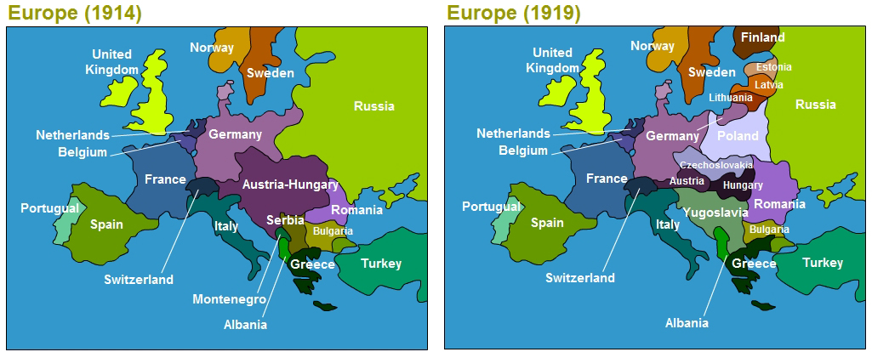
Important Points
- The Allies did not follow the 14 points.
- A war guilt clause was written into the peace treaty, blaming Germany.
- Austria-Hungary attacked Serbia after Archduke Franz Ferdinand was assassinated. The rest was alliance driven.
- How is Germany to blame?
- Germany had to pay 6.6 Billion £ to its enemies. How could Germany recreate a peaceful society?
- There were obvious winners and losers in the war. No battles had been fought in Germany. The German people thought they were winning.
- World powers gathered and blamed Germany... Thus Germany developed resentments to other countries.

