The Oxford Comma
The Oxford (or serial) comma is the final comma in a list of things. For example:
Please bring me a pencil, eraser, and notebook.
The Oxford comma comes right after eraser.
Use of the Oxford comma is stylistic, meaning that some style guides demand its use while others don’t. AP Style—the style guide that newspaper reporters adhere to—does not require the use of the Oxford comma. The sentence above written in AP style would look like this:
Please bring me a pencil, eraser and notebook.
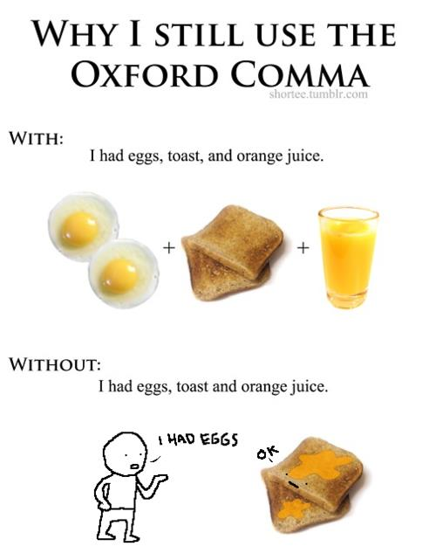
or in cases such as this one:
I love my parents, Lady Gaga and Humpty Dumpty.
Without the Oxford comma, the sentence above could be interpreted as stating that you love your parents, and your parents are Lady Gaga and Humpty Dumpty. Here’s the same sentence with the Oxford comma:
I love my parents, Lady Gaga, and Humpty Dumpty.

