Skimming and Scanning - Looking for and finding info quickly.
Your assignment today is finding 5 hotels under $200 that are in this area (Midtown Manhattan)
How: The key here is knowing what you are looking for. And where to look.
When looking for a hotel, know the area you want to stay in: In the case of this assignment, you want to stay in Midtown Manhattan: Between 60th and 34th Streets and 9th Avenue and Lexington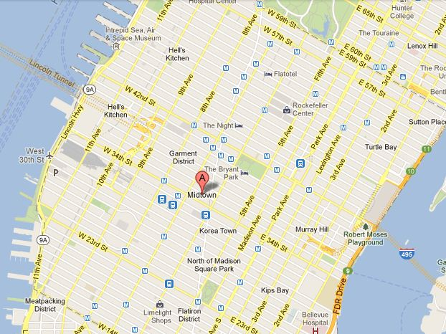
The reason you want to stay there is because it is close to the attractions: Time Square, Rockefeller Center, Bryant Park, Central Park, The Garment District and many other great things like the American Museum of Natural History
. 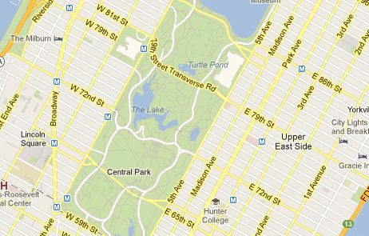
How do I know that this is where I should want to stay? Why shouldn’t I stay on the Upper East Side? The reason is that it is not in walking distance from the Theatres. We would want to walk back from Time Square at night. So we need to be close, in Midtown.

WHY: The question every student with a questioning heart asks of every task assigned by a teacher. The reason? Because you will not be able to find suitable hotels if you don’t know where they should be located.
- Search redtag.ca, travelocity, hotwire, hotels.com for 6 hotels under $200 of sufficient quality. Remember, there are 3 steps in finding such hotels. Look for these things in order.
First: Price Second: Location Third: Quality
5 Hotels under $200 in Midtown, NYC
Name  1. | Price | Address | Star Rating
2.
3.
4.
5.
6.

