Introduction
Following the end of World War II, wartime alliances soon fell apart. Without the Nazis as a common enemy, other interests and challenges occupied the nations that had defeated Germany and Japan.
In particular, Russia (and then the USSR) had lost millions of lives (soldiers as well as civilians) during invasions from the West during the two world wars. With this in mind, it focused its resources on its own security and interests. Not surprisingly, the USSR distrusted the West (and in particular the US) and wanted to ensure its safety from any future attacks. Over the course of the two wars, the USSR had fully adopted a communist and totalitarian system. The capitalist and democratic West, led by the United States, rejected the idea of communism and opposed the USSR's totalitarian methods. They also feared the USSR's desire to spread communist revolution worldwide.
As a result of these differences, Russia and the West found themselves in opposition immediately after wars where they had fought as allies. We call this opposition, which started soon after World War II, the Cold War ("Cold" because the two superpowers, Russia and the US, never engaged in a direct, or "hot," war with each other). It continued into the 1990s, affecting world events and relationships for over 50 years and influencing world issues to this very day. It was particularly influenced by the atomic age and the potential for nuclear warfare.
Module ObjectivesOn successfully completing this module, you will be able to:
- explain the concepts of cold war, containment and arms race (in the context of the Cold War).
- explain how the peril of nuclear weapons defined the Cold War era and how Western society responded to that threat.
- explain anti-communism as a western phenomenon, and compare with the modern day "war on terror."
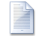
modhist112_mod8_learning_guide.doc
Download File

Important Terms: Truman Doctrine, Marshall Plan, Satellite States, Deterrence, MAD, Arms Race, NATO, Warsaw Pact, SEATO, CENTO. Communism, Capitalism, War by Proxy, 1980 Summer Olympics, Bolsheviks, Commonwealth of Independent States (CIS), Containment, Eastern Bloc, Glasnost, KGB, Perestroika, SALT, START I, START II,
Important People: Kim II-sung, USAMGIK, Syngman Rhee, Ho Chi Minh, Ngo Din Diem, Pol Pot, Harry S. Truman, Stalin, Kruschchev, Brezhnev, Gorbchev, Yeltsin, Castro, Eisenhower, Kennedy, Johnson, Nixon, Ford, Carter, Reagan, Tito, Charles de Galle, Joseph McCarthy.
The Division of Europe
As World War II neared its end, the Soviet army had marched across Eastern Europe, driving out the Nazis. Britain, the US, Canada and other allies advanced from the west and south. Unlike the other allied countries, however, the Soviet troops stayed in all of the areas that they liberated from the Nazis. The USSR occupied Eastern Europe. It created a zone of states along its borders that it could use as a buffer against any future attacks from the west. The presence of the Red Army and Soviet political organizers made sure that these nations went along with whatever the USSR wanted.
Since they acted as one, these nations were referred to as the Eastern Bloc. The Soviets strengthened the borders between the Eastern Bloc and Western Europe to keep western influences out and eastern citizens in. Winston Churchill christened this string of borders the Iron Curtain.
From Stettin in the Baltic to Trieste in the Adriatic, an iron curtain has descended across the Continent. Behind that line lie all the capitals of the ancient states of Central and Eastern Europe...All these famous cities...lie in what I must call the Soviet sphere, and all are subject in one form or another, not only to Soviet influence but also to a very high and, in many cases, increasing measure of control from Moscow.
If Eastern Europe was firmly in the Soviet sphere of influence after 1945, Western Europe was in the American sphere. The western European allies (with the support of Canada and the USA) had liberated their own homelands from the Nazis during the war. At the end of the war, they occupied the western sectors of Germany. Unlike the USSR, the West did not control foreign countries except for part of Germany. Each liberated nation was again under the democratic control of its own people.
Although the western allied powers did occupy and control the western part of Germany following the war, their occupation was only temporarily. The western allies shared common values and a belief in freedom and democracy. Together, they supported an independent and democratic Germany as it rose from the ashes of the Third Reich.
The Communist Threat
Following the war, the governments and economies of both Greece and Turkey were weakened. The Soviet Union supported revolutionary movements in each country that were working to replace the existing governments with Soviet-controlled, communist puppet states.
The British government supported the anti-communist governments of Greece and Turkey as long as they could. The war had exhausted Britain's resources, though, and by 1947 they were no longer able to continue their support of Greece and Turkey.
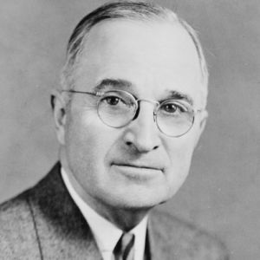
Unwilling to see a further extension of communist influence in Europe, American President Harry Truman persuaded Congress (the American government) to extend aid to Greece and Turkey. In a speech to Congress, Truman expressed what became known as the Truman Doctrine, when he said:
"It must be the policy of the United States to support free peoples who are resisting attempted subjugation by armed minorities or by outside pressures." - President Harry S. Truman, Speech to Congress, March 12, 1947
In other words, American policy must aim to stop the spread of communism in the world. (Or... "supporting free people, resisting subjugation" could be read as fight communism in any country where Communism appears to be spreading, whether we are wanted there, or not) Read this how you want, depending on your beliefs and bias.
This clearly put the former allies in opposite camps and ended any pretense of continuing the wartime alliance. The common enemy that had united the USSR and the West was gone. Different fears, priorities and beliefs now divided them.
Rebuilding Europe
President Truman realized that support for established governments against communist revolutionaries was not enough. The reconstruction of war-torn Europe and the creation of a strong, democratic Germany were essential to prevent the spread of communism further west in Europe. So America did not withdraw from world affairs as it had after World War I. Realizing that the U.S.A. was the only nation with an economy strong enough to help Europe recover, American post-war policy supported the reconstruction of Western Europe with aid dollars.
American aid to Europe came in the form of the Marshall Plan. The plan became law with the Economic Cooperation Act of 1948. Simply put, the Americans supplied billions of dollars in credit (to be paid back) to European nations, so that they could purchase everything they needed to rebuild transport networks, industries, towns and cities. Even western Germany received considerable assistance. Of course, the money had to be used to buy American goods, so this was very good for the American economy too. Everyone, except the Soviets, was happy with the Marshall Plan. A prosperous and rebuilt Western Europe was not likely to fall to communism. It also posed a potential military threat to the USSR.
The Soviets did not want a strong Germany, democratic or not, on their borders again. The previous 40 years, with two German invasions and tens of millions of dead Russians, gave them reason to fear renewed German power. Stalin favoured a weak central Europe that could not threaten the USSR.
Stalin also feared the Marshall Plan was an attempt to increase American influence in Europe. He could not stop the American plan altogether, but he did prevent any Eastern Bloc nation from taking the offered aid. Consequently, Western Europe rebuilt quickly, while the Eastern Bloc economies remained crippled by wartime damage and Soviet control. The West regained its prosperity, while the East lagged behind.
The Truman Doctrine clearly stated post-war American opposition to communism. The Marshall Plan, and the Soviet response to it, eventually led to massive differences in prosperity between East and West. Together, the doctrine and the plan put America squarely in opposition to the Soviet Union. They can be viewed as the first skirmish of the Cold War.
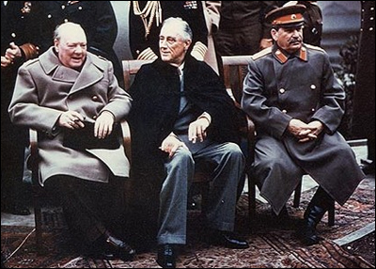
Looking at the picture above, what can be inferred from it about this meeting?
Churchill (left) with Roosevelt (USA, middle)
and Stalin (USSR, right) at the Yalta summit
Source: Wikimedia Commons image from US archives
The Berlin Blockade
​the Truman Doctrine, and the Marshall Plan were the first skirmishes of the Cold War. The Berlin blockade was its first pitched battle. Stalin wanted to counter growing American influence and force the western allies to rethink their plans to rebuild a strong Germany. In 1948, Stalin made Berlin the focus of his efforts to get his way.
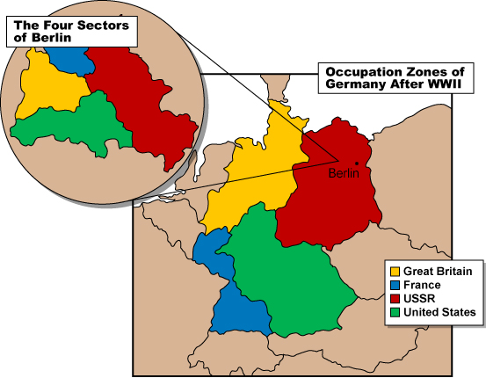
Since 1945, Berlin had been an occupied city. Each of the four main World War II Allies controlled a section of it; however, the city itself was isolated deep in Soviet-controlled East Germany. At first, the Soviets permitted western transport to move people and supplies in and out of the city, through the Soviet zone. On June 24, 1948, the Red Army suddenly closed the roads and railroads into Berlin. There was no way to get food and fuel into the city without giving in to Soviet demands and giving up Berlin to communist control.
The West mounted a huge air operation to supply Berlin's two and a half million people. It seemed an impossible task, given the smaller size of planes at that time. Starting in the summer of 1948 and continuing through the winter into 1949, cargo planes and bombers landed at Berlin's two major airports every 90 seconds, 24 hours a day. Despite their small size, these planes had to carry all the food that Berlin's citizens needed and all the fuel to heat the city during the long winter months. The planes were unloaded as fast as possible and returned to the West for more supplies.
As the planes of the Berlin Airlift flew over East German air space, fighters from the Soviet Air Force buzzed and harassed them. However, the Soviets did not have the nerve to order an Allied plane shot down. America was still the world's only atomic power and even Stalin was not ready to take that particular risk.
By May of 1949, the impossible airlift was clearly working. Without any fanfare, the Soviets reopened the roads and rail lines to Berlin and again permitted supplies to be transported across East Germany. In thisfirst confrontation of the Cold War, the Soviets backed down. Behind the scenes however, they were working to even things up by building a Soviet atomic bomb.
The USSR exploded its first atomic bomb on August 29, 1949. In future confrontations, the odds would be more even, but the stakes would be greater.
A Shift in Nuclear PowerThe evidence of the World Wars of the first half of the twentieth century proves that conflicts between great powers are always serious and always costly to the world. The Cold War added a new twist: the threat of the end of the human race in a nuclear holocaust.
Having sole possession of atomic weapons made the U.S.A. untouchable after 1945. No one would dare attack her. Such power also meant that the United States could attack other countries at will, if she wished to.
Soviet policy was to get its own atomic weapons, so that any attack by American forces would be too costly to the U.S.A. The Soviets were not ready to let America have such a huge advantage, as it would enable America to dominate the world. In 1949, the USSR exploded an atomic bomb, and the balance of power in the world shifted.
From 1949, the world worried that one side or the other would actually use atomic weapons against the other, and trigger a nuclear war.
In the late 1940s, the world was just beginning to learn the effects of atomic weapons from studies in the devastated Japanese cities of Hiroshima and Nagasaki.
The Danger IncreasesAtomic weapons in the hands of two hostile powers was bad enough but the situation soon got worse.
In November 1952, the USA exploded a hydrogen bomb in the air, just above the tiny island Elugelab in a South Pacific atoll (chain of islands). The explosion replaced Elugelab with a crater a half-mile deep. This test—codenamed Ivy Mike—showed that the destructive power of nuclear weapons had vastly increased since the Hiroshima and Nagasaki bombs. Click here to read a bit more about this.
The test astonished even informed observers. The fireball reached 57,000 feet. The mushroom cloud grew to be almost 100 miles wide. The island test site disappeared and was replaced with a mile-wide crater. Life on the surrounding islands was annihilated. Three miles from ground zero (the point directly below the explosion), no living animals were left and only the stumps of vegetation remained.
By August of 1953, the Soviets had also tested a hydrogen bomb. Such thermonuclear devicesmultiplied killing power almost beyond measure and made the destruction of the entire human race a real possibility.
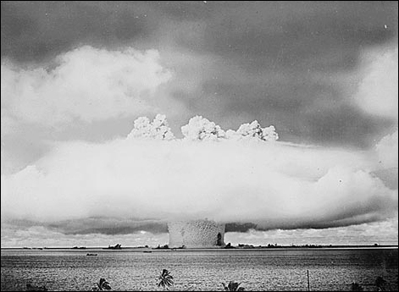
The "Baker" underwater nuclear test at Bikini Atoll - July 1946
Ships surrounding the blast area show the scale of the mushroom cloud.
Note: "Ivy Mike" was exploded above the water, and was far larger than Baker.
Source: United States National Archives and Records Administration
The Madness of MADAs the Americans and Soviets played a terrifying game of catch-up with their nuclear weapons, they both also developed better radar detection and the ability to launch their missiles almost instantly. This meant that if one nation launched a nuclear first strike, the other would have time to launch a counter strike. Although the country that was attacked would be wiped out, it was certain that the attacking nation would also be destroyed by the nuclear counter-attack. This situation made it obvious that no one could win a nuclear war.
So long as neither side developed the ability to attack the other without triggering a counter-attack, neither side dared to use nuclear weapons against the other. In a strange way, security depended on any attack bringing massive retaliation, deterring any thought of beginning a nuclear war. This was referred to asdeterrence.
So long as each side had about the same ability to destroy humanity, and the capability of launching a counter strike no matter what happened, neither power dared act.
This concept is called the doctrine of Mutually Assured Destruction, often fittingly shortened to MAD. This version of the old balance-of-power idea depended on the two sides staying equally powerful. Neither side could afford to fall behind the other in the production and development of weapons or bomb delivery systems.
To read more about bomb delivery systems, click here.MAD lead to a massive, expensive arms race that lasted throughout the Cold War era. The arms race led to the stockpiling of enough nuclear weapons to kill every human being on the planet hundreds of times over.
The MAD Club GrowsDuring the 1950s and 1960s, other countries developed nuclear weapons, and the problem of maintaining a balance of nuclear power grew. The United Kingdom joined the nuclear club in 1957, France in 1960 and Communist China in 1964. India first tested a nuclear device in 1974, and in 1998, both it and neighbouring Pakistan exploded nuclear devices. Israel is alleged to have nuclear weapons, but this has never been confirmed or denied by the government; most nations believe the Israelis do have them. Since 2000, communist North Korea has claimed to have nuclear weapons and has been taken seriously. Iran is also suspected of developing a nuclear bomb. Attempts to control the spread of nuclear weapons, with a nuclear test ban and non-proliferation treaties, have had limited success.
A new problem, now that the USSR has collapsed, is that nuclear weapons from the old Soviet arsenal may find their way into the hands of terrorists. The fear is that the threat of retaliation will not deter them from using nuclear weapons. Terrorists are often seen as fanatics or extremists who have little to lose. Unlike the governments of developed nations, terrorists are loyal to ideals or beliefs, rather than geographic areas and the people who live there. Since terrorists are usually not tied to a specific country and do not represent any country, their enemies would have a difficult time identifying a target to strike back at.
​
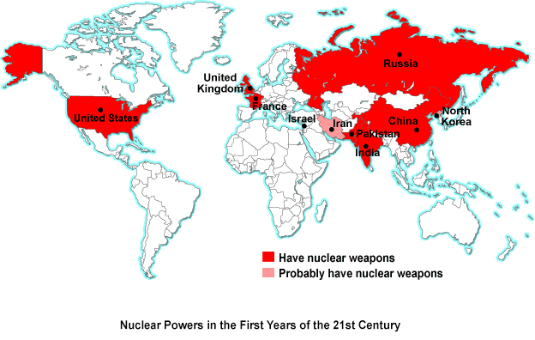
The Cold War Divisions - 1960This map shows how the countries of the world were divided during the Cold War. This 1960 division remained essentially the same until the end of the 20th century. Fewer countries had nuclear weapons in 1960 than what the map on the previous page shows for the early years of the 21st century.
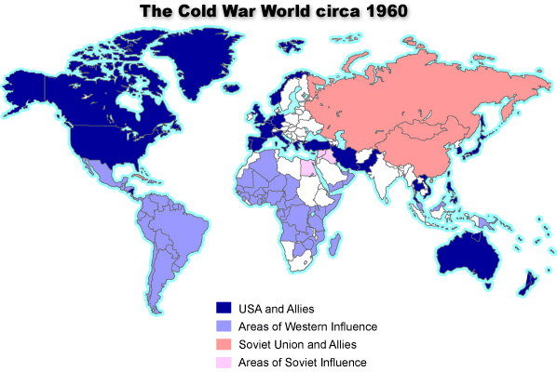
Source: Adapted from Matthew White, Historical Atlas of the Twentieth Century
The Cold War dominated world affairs during the second half of the 20th century. Very few important international decisions were made without thinking about their effect on the balance of power between the communist world and the West. Although the two superpowers never went to war directly (never engaged in a hot war), the tension between them remained high throughout the cold War.
To civilians on either side, the Cold War was not a distant conflict. The fear of nuclear destruction was everywhere. In the 1950s and 1960s, North Americans built backyard bomb shelters so that they might survive the coming war. During the Cuban Missile Crisis of the early 1960s, CBC radio broadcast instructions on what to do when, not if, the nuclear bombs starting falling on Canada. The fear as real and immediate. It seemed the end was near. Not surprisingly, the 1960s generation became involved with issues of peace. The well-known peace sign, flashed by hippies, originated in a Ban the Bomb symbol used by British marchers in the 1950s. In the 1990s, Japanese children still used the peace sign as a greeting, much as you might wave to someone.
War By ProxyWhile MAD kept the superpowers from attacking each other during the Cold War, it did not prevent them from finding other ways to struggle over power and control in the world. Instead of doing battle with each other directly, The U.S.A. and the USSR often clashed indirectly through wars and conflicts involving other countries. The superpowers would arm these other countries and advise them as they fought, but the superpowers themselves would never meet each other on the battlefield. Wars like these are called proxy wars, or war by proxy ("proxy" means a substitute or stand-in who acts for you).
In the early 1960s, America and the Soviet Union did come close to direct confrontation over a third country, but with the fear of mutual destruction in mind, they quickly found a peaceful solution.
Cold War Confrontations: The Korean ConflictDuring the first decades of the 20th century, Japan controlled Korea. In August of 1945, as World War II drew to a close and Japanese military power was crushed, the Soviet Union and the US agreed to divide Korea into two zones along the 38th parallel. Each country would take temporary control of one zone, until reunification and elections of a new government after the war.
US and Soviet relations continued to deteriorate following the end of the war. Not surprisingly, their own styles of government influenced the styles of government that emerged in the two Korean zones that they controlled: the North with a Communist government and the South with an anti-communist one.
In June of 1950, with the support of the Soviet Union, North Korean troops invaded South Korea. The United Nations—formed at the end of the war to prevent another major war—backed the US troops that were sent out to repel the invasion.
By October, UN forces (mostly American), crossed into North Korea with the aim of unifying Korea. The Chinese reacted by sending troops into North Korea to push the UN forces back. This back-and-forth confrontation would continue with no real progress on either side.
An armistice was declared in 1953, after three years of fighting led to no final victory. The 38th parallel remains, to this day, as the boundary between North and South Korea. Relations between the two remain tense, as do relations between North Korea and most of the world. Over recent years, North Korea has also become a nuclear power, which is a concern for the rest of the world.
​
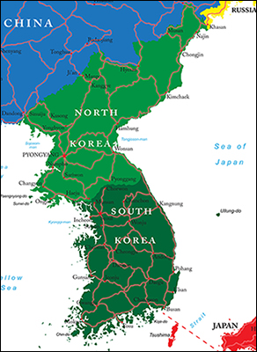
​Cold War Confrontations:
The Cuban Missile Crisis
The Cuban Missile Crisis is regarded as the closest the world has ever come to nuclear war. In 1962, the United States and the Soviet Union were in conflict. Nikita Khrushchev, the Soviet Leader, was worried about the fact that the US had nuclear missiles in Turkey that could easily reach the USSR, only 150 miles away. They also knew the Americans had more missiles then they did.
At the same time, Cuba also feared a US invasion, and turned to the Soviets for protection. Khrushchev was happy to place nuclear missiles in Cuba, only 90 miles from the American coast. With the installation of Soviet missiles in Cuba, the Crisis was on. Neither the USSR nor the US wanted to take the first step towards a nuclear war, but they were also not willing to back down. Both countries were on alert and preparing for possible war.
John F. Kennedy, the US President, chose to impose a naval blockade around Cuba to prevent Soviet ships from getting through. He also demanded that the Soviet missiles be removed. At first, Khrushchev replied that he would remove the missiles if the US promised not to invade Cuba. Later, though, he questioned why the USSR could not have missiles in Cuba while the Americans had missiles in Turkey. The situation grew more tense as the days passed.
Kennedy did not back down. He continued to say only that if the USSR removed the missiles, the USA would end the quarantine of Cuba and would promise not to invade the island. If the Soviets did not respond, the US would conduct a military invasion of Cuba. Finally, on the day the US had given as a deadline, the USSR agreed to remove the missiles, ending the crisis. The missiles were removed.
With the threat of nuclear war looming, it was a tense time. It did, however, lead to further discussion on nuclear weapons, and the creation of a partial nuclear test ban treaty (the 1963 Limited Test Ban Treaty) which banned the testing of nuclear weapons anywhere but underground.
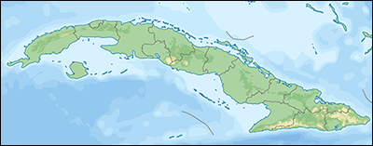
Cold War Confrontation:
Conflict in Vietnam
​Prior to the war, Vietnam had been under French colonial rule. In 1945, the Vietminh, an alliance of Vietnamese groups under Communist leadership and led by Ho Chi Minh, seized power in Vietnam. Ho Chi Minh was then elected president of a new republic centred in Hanoi. France refused to accept this new leadership and seized the Southern part of the country to try to retain power.
For years, the two fought for control of Vietnam. In 1954, France agreed to a peace settlement, dividing Vietnam into two parts. Like Korea, the North was Communist and the south non-Communist. They agreed to hold elections and form a single government, but this did not happen, and the conflict continued.
The United States provided aid to South Vietnam to oppose the spread of communism. By the mid-1960s, the US had become deeply engaged in the conflict. In 1965, President Johnston sent US troops to prevent the Communists from seizing power. The two sides became locked in a stalemate, with neither making any progress. This conflict resulted in high casualties, both within the forces and among civilians.
In 1973, after years of protest in the US and with little hope of success, President Nixon agreed to withdraw US forces. Within two years, Vietnam had been reunited under the banner of Communism. By the end of 1975, two neighbouring countries—Laos and Cambodia—had Communist governments but Communism did not spread as the US had feared.
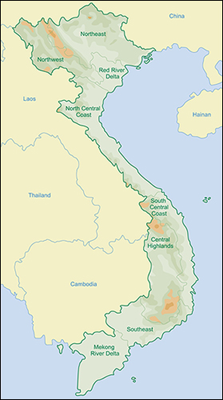
Discontent in the Eastern Bloc
From early in the Soviet occupation of Eastern Europe, there was discontent in the occupied nations of the Communist Bloc (the group of communist countries in central and eastern Europe, also called the Eastern Bloc).
East Germany (German Democratic Republic, GDR)In 1953, East Germans protested against their Soviet occupiers, but Soviet tanks crushed the uprising.
Throughout the 1950s and into the 1960s, millions of East Germans fled communist East Germany, despite a heavily guarded and fortified border. Discontent was so great that, in 1961, the communist government built a wall to keep people in.
The Berlin Wall divided the city with a high, concrete barrier topped with barbed wire. Spotlights, minefields, watchtowers and a "no man's land" guarded the approaches to the wall. East German border guards shot any East German entering the no man's land hoping to cross the wall into the West.
The much-hated Berlin Wall made the Iron Curtain terribly real. It became a symbol of the imprisonment of millions under Soviet domination.
HungaryIn 1956, Hungarians rose in rebellion against the Soviet-backed communist government. The Red Army's tanks were called in and the rebellion was crushed. Hungarian refugees fled to all parts of the globe, including Canada, to escape.
Czechoslovakia
​In 1968, the leader of the Czech government, Alexander Dubcek, tried to introduce some reforms to communism as it was practiced in Czechoslovakia.
Known as the Prague Spring, these reforms were not an attempt to overthrow communism, but simply a move to reform it. Dubcek tried to increased individual freedoms and create a more effective and local government structure.
Before the end of that year, Soviet tanks rolled in to crush the reform movement.
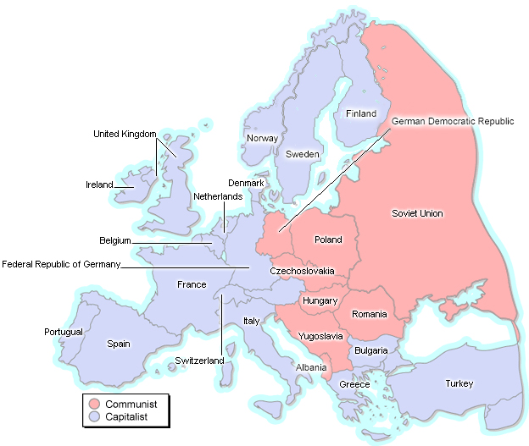
Opening the Iron Curtain
​In the 1980s, changes throughout the Communist Bloc began a process that would see it crumble before the end of the 20th century.
Poland
The beginning of the end for the Eastern Bloc came in Poland in the 1980s when a trade union, known in the West as Solidarity, successfully challenged the Polish communist government. Under the leadership of Lech Walesa, Solidarity agitated for improved conditions, more freedom for the Poles, and democratic reforms. World opinion supported Solidarity. Although the communist government tried to suppress the movement, times had changed by the mid-1980s. The Soviet Union, under its reforming president Mikhail Gorbachev, did not send in the tanks. The Soviet Union advised the Polish communist government to resolve its own problems.
In 1990, the first free elections in communist eastern Europe were held in Poland. Even after being imprisoned and harassed by the authorities for years, Solidarity leader Lech Walesa won and became president of Poland. The unravelling of the Eastern Bloc was about to take place at an astonishing speed.
Hungary
Free elections and the acceptance of a communist defeat in Poland sent the message that change would be tolerated elsewhere in eastern Europe. Aware that Gorbachev was not likely to send in the Soviet forces, Hungary allowed East German visitors to avoid the Berlin Wall by using Hungary as a travel route to the West. Hundreds of thousands of East Germans fled to West Germany.
East Germany
Protest against the communist government of East Germany also grew. Soviet President Gorbachev made it clear to the East German authorities that troops from the USSR would not be used to maintain communist rule and, in 1989, the border between the two Germanies was reopened. In 1990, the Berlin Wall was torn down, to the delight of all. Before the end of 1990, East and West Germany had been reunited as one country.
Czechoslovakia
Also in 1989, the so-called Velvet Revolution was taking place in Czechoslovakia. Playwright and long-time opponent of communism, Vaclav Havel, was elected President. His program of democratic reforms ended decades of communist repression and dictatorship. After Czechoslovakia split peacefully into the Czech Republic and the Slovak Republic in 1993, Havel was elected as president of the Czech Republic.
The world was taken by surprise by the speed of these events. In the mid-1980s, American President Ronald Regan had spoken of the "evil empire" when referring to the Soviet Union and its allies. America and the West saw them as militarily strong and the most dangerous threat to the West; however, between 1989 and 1991, the whole Eastern Bloc collapsed completely and with a speed that astonished everyone, not least of all its own leaders.
Yugoslavia's Separate Path to Collapse Yugoslavia had also been a communist state since World War II. Under the rule of Marshall Tito, it had kept some independence from the USSR, but it was plagued by the same problems of nationalism that had caused tensions in the Balkans in 1914. Marshall Tito's leadership was all that held Yugoslavia together.
Marshall Tito died in 1980. From that time, a series of wars between various national and religious groups broke out and Yugoslavia was divided into many countries: Serbia, Montenegro, Slovenia, Croatia and Bosnia-Herzegovina. War between the different nationalities, as well as between Christians and Muslims, only increased ethnic and religious hatred. Large-scale, racially motivated mass murder—called ethnic cleansing in this conflict—appeared in Europe for the first time since the Nazis.
Unfortunately, the fall of the last Balkan communist governments in 1991 did not bring peace to the region.
USSR's Costly War in Afghanistan
In 1979, a decade before the collapse of Eastern Europe, the USSR invaded Afghanistan. They did this to support a communist Afghan government against the armed opposition of Muslim religious groups called the mujahedeen.
In the 1970s, the policy of detente had improved relations between the Communist Bloc and the West. The Afghan War of the 1980s changed all that. Fearing that this move by the USSR was a sign of more military action yet to come, the West armed and trained the mujahedeen to fight the Soviet occupying forces.
Elected President of the U.S.A. in 1980, Ronald Reagan promised to build more nuclear weapons to safeguard the United States from the Soviets. Reagan'sStrategic Defence Initiative, commonly referred to as Star Wars, intended to put military systems in space. It revived the arms race and heightened the fear of nuclear war.
Eventually, the Soviets withdrew, but only after great loss of life and expense. The cost of its failed Afghan occupation, and the way the mighty Red Army had lost to lightly armed Muslim fighters caused people in the Soviet Union to question their leaders. Government policy was questioned and discontent grew. Some have called the 1980s' Afghani war the Soviet Vietnam.
Perhaps more importantly, the renewed arms race was more costly than the Soviet Union could bear. Soviet industry was inefficient and could not handle the demands of building new weapons systems. After 1985, the Soviet government, under President Mikhail Gorbachev, was also less willing to divert all economic resources to keeping up with the United States military.
An Unexpected OutcomeAfter the Soviets left Afghanistan, the mujahedeen installed the Taliban government. Ironically, it was that government, and fighters trained by Americans, that the United States went to war with after Sept 11, 2001 as part of its war on terrorism.
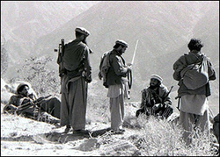
Mujahideen in Kunar, Afghanistan, 1987
Photo by Erwin Lux
Source: Wikimedia Commons under
a limited Creative Commons license

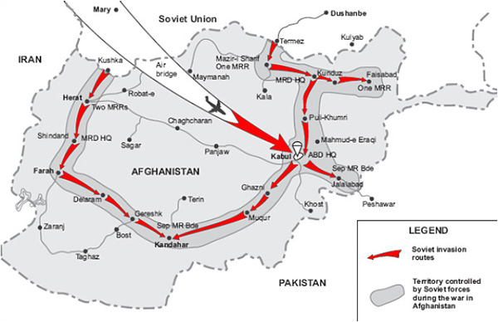
Public domain image from U.S. Army via Wikimedia Commons

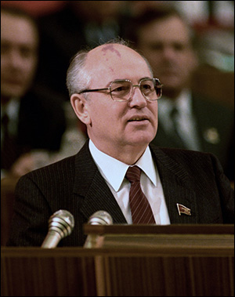
Mikhail Gorbachev, President of the USSR
Source: RIA Novosti archive, image
# / CC-BY-SA 3.0 Via Wikimedia Commons

Mikhail Gorbachev: USSR's Reforming Statesman
Between 1985 and 1991, Soviet political leader Mikhail Gorbachev made important changes in the way the USSR was run. As both the as General Secretary of the Communist Party of the Soviet Union, and the only president in the history of the USSR, Gorbachev developed a policy of reorganizing the Soviet economy that he calledPerestroika. His goal was to modernize the economy and create social and economic growth. In other words, Perestroika was intended to create more wealth for the USSR by bringing industry up to date.
The other major change under Gorbachev was a result of his policy of glasnost. Under this policy of openness, criticism of government policies would be tolerated, even encouraged, for the first time in the USSR. Gorbachev believed this would allow suggestions for improvements to come forward. Dissenters were released from prison. Protests increased. Intellectuals spoke openly against communist policies and practices. The reform movement gathered support and demanded that Gorbachev make changes much more quickly than was happening.
Of course, the old-time communists in the USSR did not like Gorbachev's changes. They were losing control of power and not following party principles. They wanted things to go back to the way they had been. In 1991, they tried to stage a coup to throw Gorbachev out of office and take back power. They failed and the Communist Party was outlawed in the very nation that had experienced the first successful communist revolution back in 1917! The result was the end of Soviet control over the Communist Bloc countries, and therefore the end of the USSR as a single unit. Following the coup, Russia (the largest and most powerful republic in the Soviet Union) found itself surrounded by newly independent republics.
Still under pressure from the reformers, Gorbachev was forced to resign ate in 1991 and Boris Yeltsin, the leader of the reformers, became president of Russia.
Post-USSR Russia
After communism was outlawed in 1991, the USSR came apart. Fifteen independent states appeared in its place.
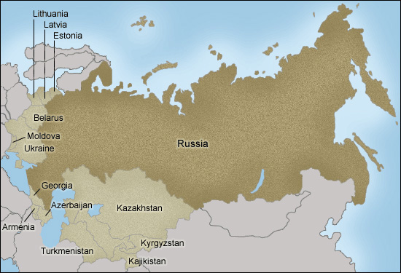
The End of the Cold WarAlthough the 1991 ban on communism in the USSR, and the subsequent breakup of the Soviet state into 15 separate nations, brought about confusion and uncertainty, it did mark the end of the Cold War.
Although communist China was still a serious concern at that time (changes during the 1990s and early 2000s slowly made it less of a threat), a communist superpower no longer opposed the ideas of western democracy. No superpower could counter American influence in the world, and no longer was there the immediate threat of nuclear destruction.
The joy at the end of the Cold War was short lived, however. People soon realized that the world still contained the same number of nuclear weapons, but now they were not as well controlled. Fears grew about who would get their hands on former Soviet nuclear arms.
New enemies began to emerge as terrorist threats replaced the threat from the former USSR. These new threats were even more of a worry. Terrorists, after all, are much less predictable than the government of even the former USSR, and have little to lose by using nuclear, chemical or biological weapons.
​
Proudly powered by Weebly

