What were the main features of the geography of Greece?

____________________________________________________________________________________________________________________________________________________________________________________________________________________________________________________________________________________________________________________________________________________How did the mountains and the sea affect life in Greece?

____________________________________________________________________________________________________________________________________________________________________________________________________________________________________________________________________________________________________________________________________________________What benefits and problems are associated with mountains, deserts, rivers, or oceans? (Pick 2)

____________________________________________________________________________________________________________________________________________________________________________________________________________________________________________________________________________________________________________________________________________________What is the legendary history of Rome?

____________________________________________________________________________________________________________________________________________________________________________________________________________________________________________________________________________________________________________________________________________________Why was Rome’s location so favorable?

________________________________________________________________________________________________________________________________________________________________________________________________________________________________________________________________________________________________________________________________________________________________________________________________________________________________________________________________________________________________________________________________________________________________________________________________________________________________________________________________________________________________________What were the main geographic features of Mesopotamia, and what was good and/or bad about them?

____________________________________________________________________________________________________________________________________________________________________________________________________________________________________________________________________________________________________________________________________________________

What were the main geographic features of Egypt, and what was good and/or bad about them?

____________________________________________________________________________________________________________________________________________________________________________________________________________________________________________________________________________________________________________________________________________________

Which two civilizations are most different from one another and why?

___________________________________________________________________________________________________________________________________________________________________________________________________________________________________________________________________________________________________________________________________________________________________________________________________________________________________________________________________________________________________________________________________________________________________________________________________________________

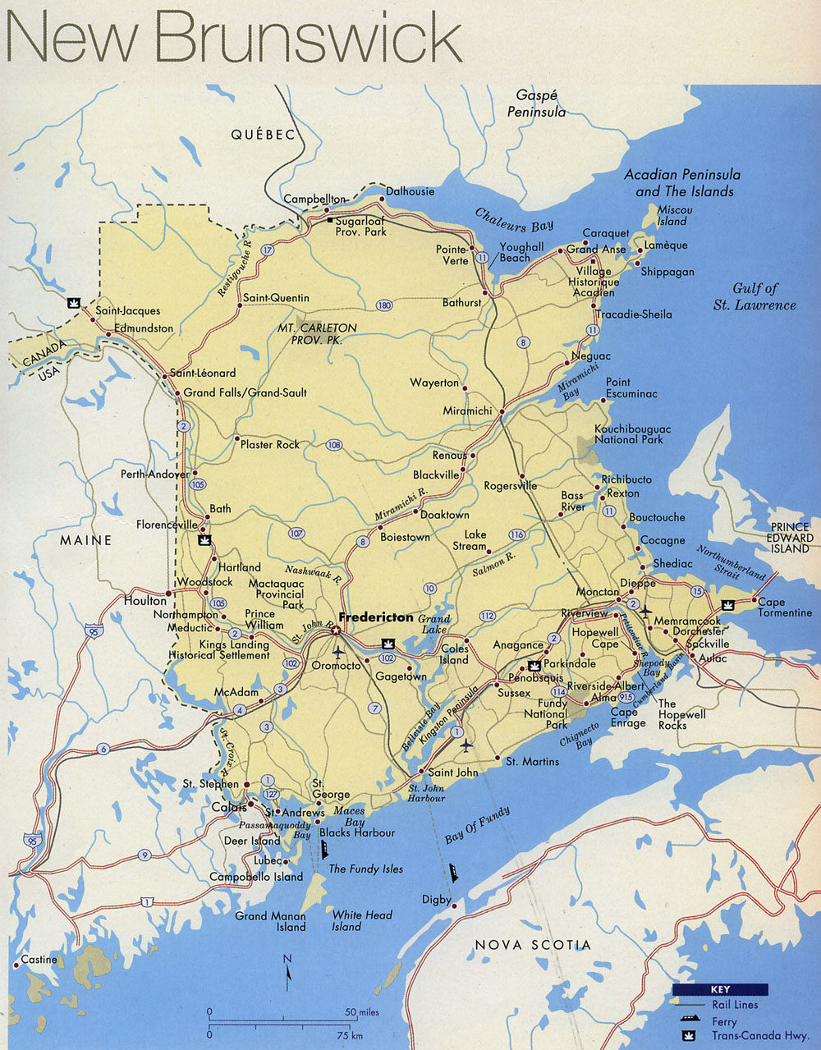What geographic factors are favorable in New Brunswick?



_________________________________

_________________________________

_________________________________

________________________________

_________________________________

_________________________________

_________________________________

_________________________________

________________________________

_________________________________

_________________________________

_________________________________

_________________________________

_________________________________

_________________________________

_________________________________