How Headphones Changed the World
DEREK THOMPSONMAY 30 2012, 2:08 PM ET
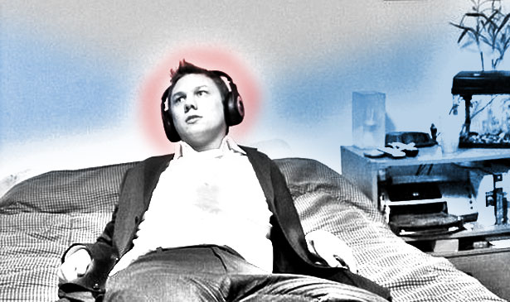
A short philosophical history of personal music

Adapted from flickr/Matthew Hickey
If you are reading this on a computer, there is an excellent chance that you are wearing, or within arm's reach of, a pair of headphones or earbuds.
To visit a modern office place is to walk into a room with a dozen songs playing simultaneously but to hear none of them. Up to half of younger workers listen to music on their headphones, and the vast majority thinks it makes us better at our jobs. In survey after survey, we report with confidence that music makes us happier, better at concentrating, and more productive.
The triumph of headphones is that they create, in a public space, an oasis of privacy
Science says we're full of it. Listening to music hurts our ability to recall other stimuli, and any pop song -- loud or soft -- reduces overall performance for both extraverts and introverts. A Taiwanesestudy linked music with lyrics to lower scores on concentration tests for college students, and other research have shown music with words scrambles our brains' verbal-processing skills. "As silence had the best overall performance it would still be advisable that people work in silence," one report drylyconcluded.
If headphones are so bad for productivity, why do so many people at work have headphones?
There is an economic answer: The United States has moved from a farming/manufacturing economy to a service economy, and more jobs "demand higher levels of concentration, reflection and creativity." This leads to a logistical answer: With 70 percent of office workers in cubicles or open work spaces, it's more important to create one's own cocoon of sound. That brings us to a psychological answer: There is evidence that music relaxes our muscles, improves our mood, and can even moderately reduce blood pressure, heart rate, and anxiety. What music steals in acute concentration, it returns to us in the form of good vibes.
That brings us finally to our final cultural answer: Headphones give us absolute control over our audio-environment, allowing us to privatize our public spaces. This is an important development for dense office environments in a service economy. But it also represents nothing less than a fundamental shift in humans' basic relationship to music.
A SHORT HISTORY OF PRIVATE MUSIC
In 1910, the Radio Division of the U.S. Navy received a freak letter from Salt Lake City written in purple ink on blue-and-pink paper. Whoever opened the envelope probably wasn't expecting to read the next Thomas Edison. But the invention contained within represented the apotheosis of one of Edison's more famous, and incomplete, discoveries: the creation of sound from electrical signals.
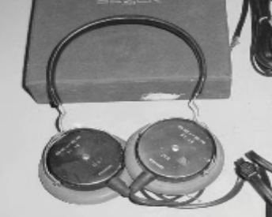The author of the violet-ink note, an eccentric Utah tinkerer named Nathaniel Baldwin, made an astonishing claim that he had built in his kitchen a new kind of headset that could amplify sound. The military asked for a sound test. They were blown away. Naval radio officersclamored for the "comfortable, efficient headset" on the brink of World War I. And so, the modern headphone was born.
The purpose of the headphone is to concentrate a quiet and private sound in the ear of the listener. This is a radical departure from music's social purpose in history. "Music together with dance co-evolved biologically and culturally to serve as a technology of social bonding," Nils L. Wallin and Björn Merker wrote in The Origins of Music. Songs don't leave behind fossils, but evidence of musical notation dates back to at least Sumeria. In 1995, archaeologists discovered a bone flute in southern Europe estimated to be 44,000 years old.
The 20th century did a number on music technology. Radio made music transmittable. Cars made music mobile. Speakers made music big, and silicon chips made music small. But headphones might represent the most important inflection point in music history.
If music evolved as a social glue for the species -- as a way to make groups and keep them together -- headphones allow music to be enjoyed friendlessly -- as a way to savor our privacy, in heightened solitude. In the 1950s, John C. Koss invented a set of stereo headphones "designed explicitly for personal music consumption," Virginia Heffernan reported for the New York Times. "In that decade, according to Keir Keightley, a professor of media studies at the University of Western Ontario, middle-class men began shutting out their families with giant headphones and hi-fi equipment." Headphones did for music what writing and literacy did for language. They made it private.
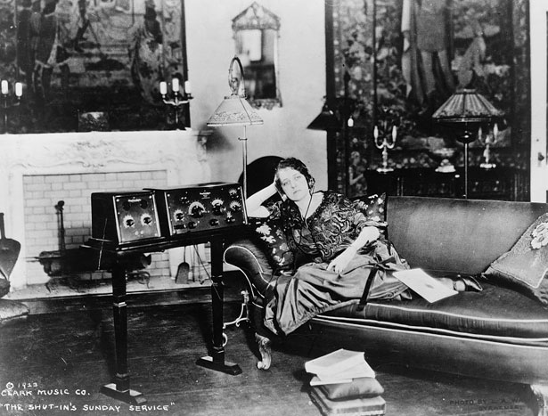
Library of Congress
ALONE, TOGETHER
Loneliness is one of the first things ordinary Americans spend their money achieving.
So wrote Stephen Marche in last month's cover story for The Atlantic. "Loneliness is at the American core, a by-product of a long-standing national appetite for independence," he said. "The price of self-determination and self-reliance has often been loneliness. Americans have always been willing to pay that price."
It is easy, and therefore popular, to say that headphones make us anti-social. But Marche is right. Wealth can buy -- and modern technology can deliver -- the independence that people have always sought. People have always had private thoughts. Headphones have the capacity to make our music like our thoughts. Something that nobody else can hear. Something we can choose to share.
Dr. Michael Bull, an expert on personal music devices from the University of Sussex, has repeatedly made the larger point that personal music devices change our relationship to public spaces. "People like to control their environment," he told Wired magazine, and "music is the most powerful medium for thought, mood and movement control."
Controlling our public environment is more important now that Americans have stopped moving away from density. Sunbelt suburbs today are languishing. Urban centers are thriving. "Today, the most valuable real estate lies in walkable urban locations," Christopher B. Leinberger reported in a new Brookings study last week. In a re-urbanized United States, the earbud is the new car stereo. "With the urban space, the more it's inhabited, the safer you feel," Bull says. "You feel safe if you can feel people there, but you don't want to interact with them."
Personal music creates a shield both for listeners and for those walking around us. Headphones make their own rules of etiquette. We assume that people wearing them are busy or oblivious, so now people wear them to appear busy or oblivious -- even without music. Wearing soundless headphones is now a common solution to productivity blocks. Baldwin's invention for the Navy has become a social accessory with a explicit message: I am here, but I am separate. In a wreck of people and activity, two plastic pieces connected by a wire create an aura of privacy.
SOUND AND WORK
We still haven't answered the first question I posed: If headphones are so bad for productivity, why do so many people work with headphones?
It's not just that headphones carve privacy out of public spaces. It is also that music causes us to relax and reflect and pause. The outcome of relaxation, reflection, and pausing won't be captured in minute-to-minute productivity metrics. In moments of extreme focus, our attention beams outward, toward the problem, rather than inward, toward the insights."When our minds are at ease -- when those alpha waves are rippling through the brain -- we're more likely to direct the spotlight of attention inward," Jonah Lehrer wrote in Imagine. "The answers have been there all along. We just weren't listening."
In a crowded world, real estate is the ultimate scarce resource, and a headphone is a small invisible fence around our minds -- making space, creating separation, helping us listen to ourselves.
>

