Modern History Test – Industrial Revolution.

Section 1: Define:
Urbanization
Socialism
Liberalism
Section 2: Multiple Choice:
- What ideology promotes laissez-faire?
- What does laissez-faire mean in terms of government regulation?
- Which of these is not a product of the Industrial Revolution?
- Why were factory workers made to work in shifts?
- Why did literary realists of the mid-nineteenth century prefer novels to poems?
Section 3: Short Answer (Choose 5 of the following questions)
- Name 3 inventors and their inventions
Inventors | Inventions
- What is the significance of Manchester and Liverpool?
- What 4 factors made England the starting place of the Industrial Revolution in Europe?
- What was the new class of people in the industrial revolution and how might their views have differed from the working class?
- What are the four (4) causes of revolution? Give examples of each of the causes of revolution, as they apply to the Industrial Revolution.
- What was the enclosure movement and how did it help create the trend in urbanization?
- Name and explain two ways that James Watt’s innovation changed the world, and spurred the industrial revolution.
- Why did people want legalized unions? What benefits could a union provide?
- Give 5 examples of things that changed during and after the Industrial Revolution.

Section 4: Analyzing Visual Texts:
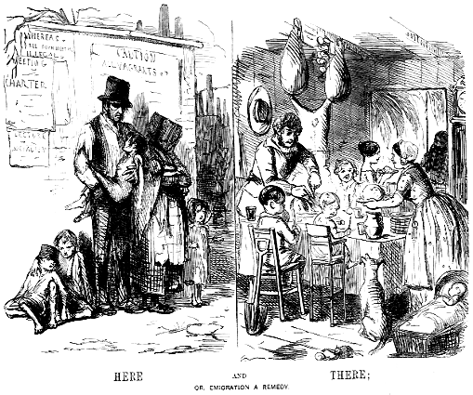

- Examine the picture and use your critical viewing skills to determine what is being said. NOTE: The cartoon appeared in PUNCH magazine, July 15th, 1848, depicting Ireland (left) and America(right)
Observation | Interpretation
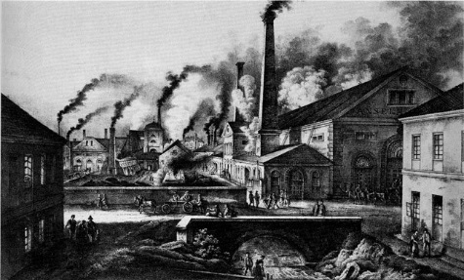
- Describe the scene above. What is it telling you about the Industrial Revolution?
Observation | Interpretation
Section 5: Literary Text Analysis: Read the text and quote sections to explain what they mean, regarding urbanization, and London in the time of the industrial revolution
William Blake’s “London”
I wander thro' each charter'd street,
Near where the charter'd Thames does flow.
And mark in every face I meet
Marks of weakness, marks of woe.

In every cry of every Man,
In every Infants cry of fear,
In every voice: in every ban,
The mind-forg'd manacles I hear

How the Chimney-sweepers cry
Every blackning Church appalls,
And the hapless Soldiers sigh
Runs in blood down Palace walls

But most thro' midnight streets I hear
How the youthful Harlots curse
Blasts the new-born Infants tear
And blights with plagues the Marriage hearse

Quoted text / Observation | Interpretation

