Why Facebook Has Change Our Lives For The Better
03 February 2014By Sam Parker
It’s become fashionable to knock a social network that more than half of Britain’s population is signed up to. But as Facebook slips into middle age, Sam Parker argues there is much to celebrate about the biggest social network

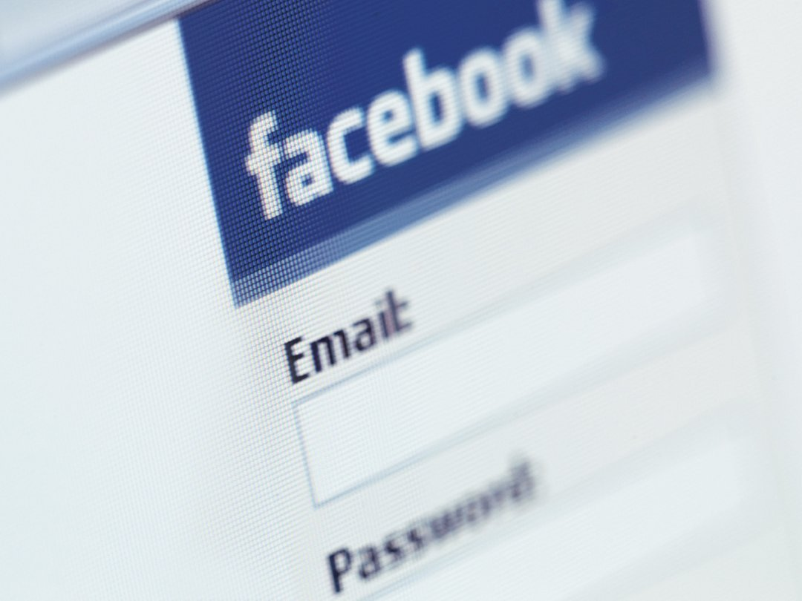
In 1982, three years before I was born, my Father was living in a tank in West Berlin. He was the ‘gunner’ in a regiment ordered to be ready in case Russia decided to turn the heat up on the Cold War and invade Germany. For several days at a time, he was locked in an armoured metal box with three other men. At 19, he was the youngest.
During such periods, they never saw daylight and were required to eat and sleep where they sat. There was Mick, the radio operator, Russell, the driver, and their commander Alan, who would later stand in for my Grandfather and give my Mother away on her wedding day. For eight years, the four of them lived together in a barrack block (when they weren’t in their tank, that is) and enjoyed exploring Spandau, getting drunk and generally being single men in their 20s.
In time, they watched each other get married and have kids. Then slowly, one by one, they left the army and lost touch. “This was before mobile phones or the internet,” my father reminds me. “And squaddies don’t exactly write each other letters.”
Twenty years, one business, a child and divorce later, it’s 2011. My Dad has discovered Facebook. Like all of the site’s later, older adopters, he takes to it with unselfconscious glee, adding me and my friends, posting pictures of his dogs and ‘liking’ The Rolling Stones, along with groups called things like ‘Yorkshire And Proud’. At some point, he also searches for the Royal Dragoon Guards.
On St Patrick’s Day, 2013, my father walked into the bar at Halifax Rugby Club, West Yorkshire. Three other men did the same. Despite the grey hair and the glasses, they all recognised each other immediately. Back in the Eighties, they shared a tank.
“It was 30 years on since we first met, but it felt more like 30 minutes had passed” is how the old man described it at the time. “We got drunk, caught up, told stories and laughed until our chests hurt.” For the four of them to be together again, he says, was “very emotional”.
“Russell’s son had been killed in Afghanistan. Two of us had been divorced. We remembered each other’s wives and children. It was amazing how life had moved on, but we were still there.”
Unbeknownst to my Dad, the reunions had been going on every year. “Now we all stay in touch regularly,” he says. “We wish each other happy birthday, see pictures of each other’s grandchildren, take the piss out of each other now and then... all on Facebook, I mean.”
***
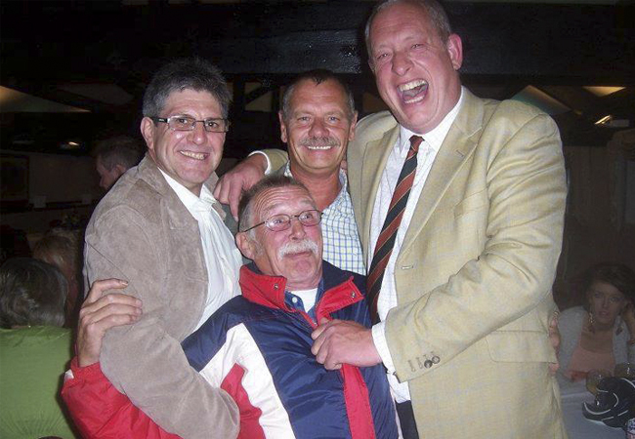Dad, far right, reunited with his army buddies, 2013
***

Ten years on from the day Facebook was founded in a Harvard University dorm room, over half of the entire population of the UK is an active user of the website.
We use it to chat to our friends, post pictures from our weekends, share links to things we like or things we think will make us look good. We use it to announce our new jobs, our engagements, our new-borns. We advertise our businesses or point to our achievements. We stalk ex-partners or perform guilty reconnaissance on potential ones. We flick through our photographs, absorbed in the story of our own lives, incredulous at the fleeting nature of time. We ‘like’ others doing these things, or cringe silently at their self-indulgence or their poor grammar. And we do all of this for an average of 15 minutes of every single day.
Facebook has replaced television as the number one time waster in our lives. And like TV, it has become fashionable to dismiss it as shallow and unhealthy, even though doing so doesn’t mean we use it any less. Speak to anyone about it and they’re likely to frown, scrunch up their nose and say something about it being ‘full of rubbish’ or the fact they ‘barely check it anymore’.
They’re lying, of course — unless they happen to be teenagers. An extensive European study carried out at the end of 2013 found that 16 to 18-year-olds were fleeing Facebook in their droves. Horrified by the site’s growing popularity among the over-50s — their parents, in other words – youngsters are migrating to Instagram and WhatsApp and SnapChat, where they can gossip and send pictures of their genitals to each other in peace.
What this means is that Facebook, at the ripe old age of ten, is maturing. It’s still getting bigger — in 2013, monthly active users grew by 18 per cent year-on-year to 1.19 billion people across the globe — but it’s being used and viewed differently to when it first burst into our lives.
The media, for one thing, is less excited about it. When was the last time you heard the number of people in a Facebook group cited in a news story? Twitter, with its hashtags and hysteria, now fulfills the role of instant social barometer.
Gone too is all scare-mongering about Facebook and how using it could cost you your job or reputation. The modern fable went that any potential employer would search through your profile and throw your application in the bin if they saw that picture of you at university downing a Sambuca with sick on your shirt. Today, the people doing the employing have that same photo online somewhere, and they’d think it more suspicious is you didn’t have a digital trail of your private life.
Facebook, then, is now settling into something like middle age. It has become a calmer, more consistent presence in our lives. No longer a novelty but a part of our digital routine, as mundane as checking our emails.
For its critics – and there are still many of those – this makes Facebook all the more insidious. But for me, as Facebook turns ten, I’d like to wish it many happy returns.
***
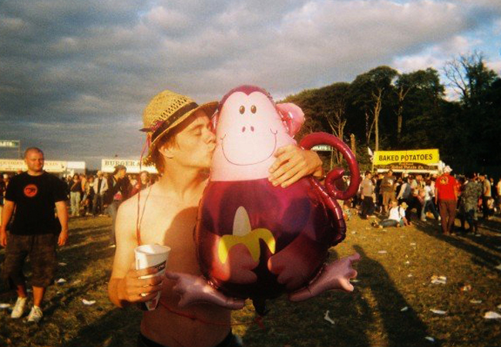At a music festival in 2007. Facebook had spread throughout UK universities
***
In 2000, when I was 15 years old, I had the kind of summer that changes a young man forever, the kind sentimental Canadian rock stars write best-selling songs about, the kind that does indeed include the ‘best days of your life’. The main reason, of course, wasn’t learning how to roll a joint properly or playing in a rubbish grunge band called ‘Frottage’ (very witty, we thought), but a girl named Debbie.
Debbie was my first serious girlfriend, and as such, the most beautiful girl in the world. She had long blonde hair, green eyes that wiped the floor with you, and cheekbones that belonged on a statue somewhere in the belly of the Louvre. We were each other’s first loves, and after a year of intense dating — make that anxious and overbearing, on my part — we split up.
The final part of our story — the part Bryan Adams ran out of verses for — came when I found out a few weeks later that she’d slept with someone else. I rang her crying and shouting, threw the phone against the wall with a howl of anguish and promptly descended into three years of bitter, sullen misery, cutting all ties with Debbie except for the reams of awful poetry I kept hidden under my bed.
Fast-forward to 2006, my second year of university. I was over Debbie, of course, but the memory of her and how I’d behaved sat like an ulcer somewhere deep in my chest, no matter how many other girls I managed to put between us.
One night at a house party — mine, as it happens — Debbie turned up out of the blue. I had designated the night an ‘event’ on Facebook, as was the fashion at the time, and through a distant chain of mutual friends she’d seen it and clicked ‘attend’.
And so it was that slumped in the corner of my bedroom, sharing a bottle of the cheapest red wine available from the local Spar, we spoke for the first time in years. We laid all the ghosts of our teenage love to rest, laughing, crying, reminiscing and (for my part) apologising. We shared one last beautifully strange night together, and I woke up the next morning understanding for the first time the meaning of the word ‘catharsis’.
Our story had been given an epilogue I had dreamed of but never thought possible. And the reason — the only reason — was Facebook.
***
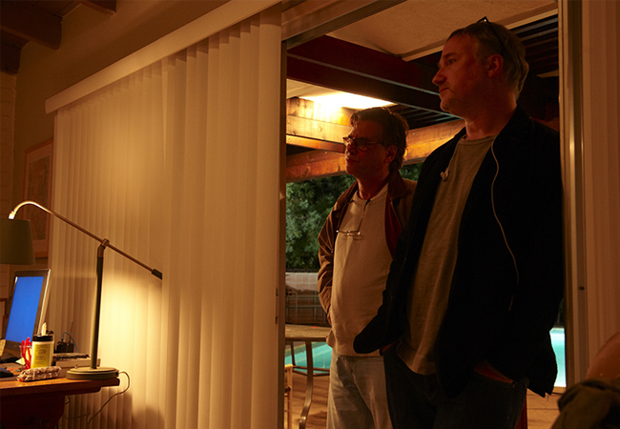The Social Network director David Fincher and writer Aaron Sorkin
***
The industrial revolution took place over 100 years and inspired not only much in the way of anxious social commentary but also art, from Orwell’sRoad To Wigan Pier to J.M. W Turner’s painting Rain, Steam and Speed, in which a tiny hare runs hopelessly from the path of an oncoming steam train (you can see it hanging in the National Gallery).
The social media revolution has changed our lives beyond recognition in a tenth of that time. From Facebook’s inception in 2004 to the present day, it has acquired 33 million daily users in the UK alone. This staggering growth has, naturally, given rise to anxious social commentary and art of its own. Literature, film and even computer games have chimed in to lament the demise of authentic human interaction and the onset of the disease that is digital narcissism.
The best-known example of ‘Facebook anxiety’ in the arts is The Social Network, a celebrated 2010 film about the life of the site’s founder Mark Zuckerberg. It painted the young entrepreneur as a social misfit (played with a sort of semi-autism by Jesse Eisenberg) who created the website as a revenge against the girl who once spurned him at university. The final scene sees Zuckerberg victorious in his legal battle to prove he owned the idea for Facebook, but ultimately alone – a man, we’re supposed to conclude, with millions of virtual friends but very few ‘real’ ones. It was a sermon, of course, not really on Zuckerberg but on social media itself, the way we engage in it at the expense of real world connections.
The inaccuracies in The Social Network were swiftly pointed out, the biggest of which being that Zuckerberg was still dating the same girl he had been with since before he invented Facebook. But the point that stuck out for me was the confession by both director David Fincher and writer Aaron Sorkin that not only were neither on Facebook, they hadn’t even seen it and didn’t really understand how it worked.
This film, for all its skilful direction and snappy dialogue, was a hatchet job by old media on the new; the hand-wringing of an elder generation bewildered by the pace of change Facebook had ushered into their world. Interestingly, it was print commentators, such as the venerable, late US film critic Roger Ebert, who declared the The Social Network his ‘film of the year’, describing it as “instinctively perceptive”.
The few critically dissenting voices included Arianna Huffington, founder of The Huffington Post, who described the film as “very Hollywood" and observed wrly, "In real life, he [Zuckerberg] was just sitting around with his friends in front of his computer, ordering pizza. Who wants to go see that for two hours?”
Other prominent artists, such as the novelists Jonathan Franzen and Dave Eggers have added their voices to the chorus of anxiety about the internet age and social networking in particular, the former with a much-mocked, semi-hysterical essay for The Guardian and the latter with an excellent if occasionally over-blown satirical novel, The Circle.
What unites much of this cultural criticism of Facebook is not that it is wrong about some of the negative affects social networking can have, but that it unanimously ignores the positive changes social networking has brought into our lives, perhaps more through ignorance than anything else.
My Dad wouldn’t have been reunited with his old army buddies without Facebook. I certainly wouldn’t have had my moment of reconciliation with my first love. But beyond those examples, there are hundreds of tiny, day-to-day joys that using the site brings to our lives that we now take for granted.
My young nieces and nephews are growing up fast in distant corners of the UK. My sister, an enthusiastic Facebooker, regularly updates her family and friends with anecdotes and pictures of their latest adventures and milestones. I can happily say the same of friends living out in China, Thailand and New York. I login and get daily snapshots from the lives of people I love but can’t see as often as I like, and I can, in turn, interact with them in comments or chat, even if it’s just to take the piss out of their new haircut (friends that is, not my sister’s children).
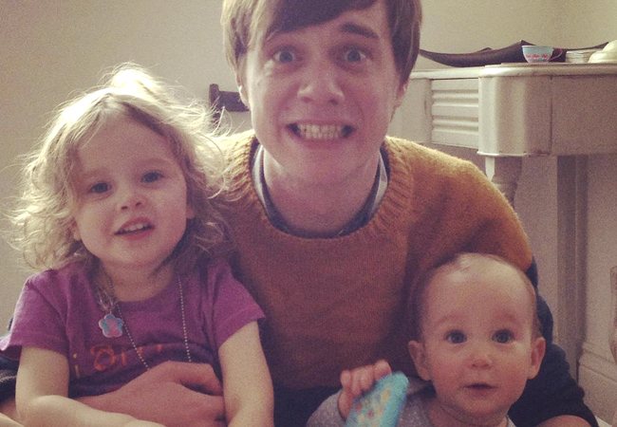
Erin (left) and Florence
Facebook’s critics would have you believe that this form of communication is a threat to the more authentic act of picking up the phone. No doubt, had they been around when Alexander Bell was doing his thing, they’d have told you picking up the phone was a threat to the more authentic act of writing a letter. I’ll just take the free opportunity to stay in touch with my loved ones, thanks very much, and see them in person when I next can.
Another fashionable criticism of Facebook is that you end up passively consuming the quotidian banalities of people you barely know or don’t like. The simple response to this is that you can have as many or as few ‘friends’ on the site as you like.
For me, though, there is a kind of poetry even to that stuff. One of my favourite people on Facebook is a good-hearted, utterly unpretentious Welshman I knew briefly at university, who regularly posts the kind of simple, declarative status updates people despair of (‘Just finished dinner, lovely day out with my son and the in-laws’).
In contrast to the carefully constructed witticisms or political diatribes of other, more articulate friends, his succinct, unassuming statements have a meditative quality I get a kick out of. Though I wouldn’t dream of calling him for a chat, I am glad for his happiness when I see it; a small, uncomplicated emotion that takes up precisely .002 seconds of my time to process.
Then there is the guy we called ‘the mole’ at school. He was the smallest, geekiest kid in class. I would have put money on him being destined for a life of timid mediocrity in some grey office block somewhere. Not so. Thanks to Facebook, I have learned in recent years he has grown into a longhaired, bearded jazz drummer and occasional world adventurer. Pictures I have flicked through show him on stage wigging out in a bandana or driving across the planes of Africa in a homemade jeep.
Facebook, in that sense, can offer the romance of a high school reunion; a living, breathing ‘where are they now’ article populated by people who conjure fleeting, happy memories from your own past. An old classmate gets married... Someone you played football with gets a new job... A drinking buddy you no longer drink with details the horrors of his latest hangover… It’s life’s rich tapestry, woven together by stream-of-consciousness outbursts, topical debates and kitten selfies.
I understand why, for many people, ‘other people’ is precisely what they hate about Facebook. And don’t get me wrong, when someone goes on a rant about Muslims or posts some pseudo-cryptic cry for attention – ‘SOME people need 2 learn to mind their own BUSINESS!!!!’ – I hate it too. So you know what I do? I remove that person from my Facebook world with the click of a button, and never feel annoyed by them again. In the age of social media, we are all writers and reporters. Some of what we have to say is heartfelt. A lot of it is preening and posturing of the worst kind. But all of it is real, a reflection of the multiple ways we sometimes behave in real life.
But the real reason I am glad for Facebook’s birthday, and hope it makes it to its 50th or 60th, is this. Before the internet, we had to accept that eventually, we’d lose touch with 99% of all the people we met in our lives – not because we ceased to care or find them interesting, but because we didn’t have the time or capacity to keep more than a handful of bonds alive.
Now, whether it’s an old army buddy or a first love, a school friend or an old work colleague, that rule no longer applies. Quietly, without fuss, we can witness each other’s stories unfold from afar, or get in touch again, even in the smallest of the ways, whenever we want. I for one think that’s worth celebrating. Or at the very least, putting on Facebook.

