Modern History 112 –

World War II / Holocaust Test

Section 1: Matching definitions (10 marks) Mandatory Section
- _______________________a system of government in which the rulers try to control all aspects of peoples' lives.
- _____________________strong leaders or juntas (military governments), who demand obedience.
- _____________________ political philosophy glorifying the state above the individual, strong central government led by dictator
- _____________________ preparing for war, both civilian and military.
- _____________________ “divine wind”, fighters who saved Japan from Kublai Khan, and fighter/bomber pilots of Japan involved in suicide missions.
- ________________________ based on a set of beliefs.
- ________________________ those of cultural or historical decent, possibly from a geographic region.
- ________________________ The act of taking and holding foreign territory.
- ________________________ The physical extermination of people.
- ________________________ what we might call those people who aided in finding and exterminating Jewish people.
Kamikaze, occupation, dictator, ethnic, totalitarianism, mobilization, collaborators, fascism, genocide, ideological
Section 2: Short answer: Mandatory section
- What is our estimate of the number of Jews killed during the Holocaust? (1)
- What is the Hebrew word for the Holocaust? (1)
- Name the leaders of the following countries, during World War II, in the order in which they are listed: Italy, Germany, England, Russia, Canada, France, and Japan. (7)
- Define Anti-Semitism? (1)
Section 3: PART 1 -Long- Answer (These are not essay questions) Pick 3.
- Who were sent to the concentration camps? (There was more than one group of people). What was life like in one of these camps? (3)
- Democracy, Communism, and Fascism were the political ideologies that ruled the inter-war period, into the Second World War. Why are these ideologies important? To which countries do they relate? How do these ideologies impact the inter-war period?
- Explain Prohibition, Flapper Girls/Harlem Renaissance (culture), and Black Friday/The Great Depression.
- What was the name of the government implemented in Germany after World War I? What form of government was it? What events in the world and in Germany caused this government to fail?
- What is total war? How is it evident in World War II?
- Why might we say that the Second World War was the beginning of modern terrorism? Explain with examples, and events.
- Describe Hitler’s Final Solution? How might the Final Solution have contributed to Nazi Germany’s defeat?
- How did the Holocaust impact Europe and the rest of the world after the war?
Section 3: PART 2 -Long- Answer (These are not essay questions) Pick 3
- What was Canada’s response to Jewish Refugees? What does this teach us about the world of the 1930s and 40s?
- What were the general causes of World War II?
- What were the consequences of World War II? Positive and Negative.
- How did the manner in which the Allies invaded Germany set up the tensions which led to the Cold War?
- Looking at the 3 major conferences between the allies toward the end of the war - Tehran, Yalta, Potsdam – how can we see the development of tensions that would lead to the Cold War?
- What did Adolf Hitler’s Nazi party promise to the German people? What did they want during the interwar period, which the Allied powers disagreed with?
- Evaluate and compare the consequences of the First World War and the Second World.
- Compare the number of Jewish people killed to all other war related death during World War II. What does this tell us, and how did the Holocaust impact the world?

Section 4: Text Analysis Choose One (Word Bank: Home front, Total War, Mobilization, Propaganda, Dehumanization, Traits)
- Evaluate and analyze the propaganda posters of the USA and Soviet Union. How are the women being depicted? How are women being portrayed? Is it favorable? How is this a change from the past? How have our representations of women changed since?
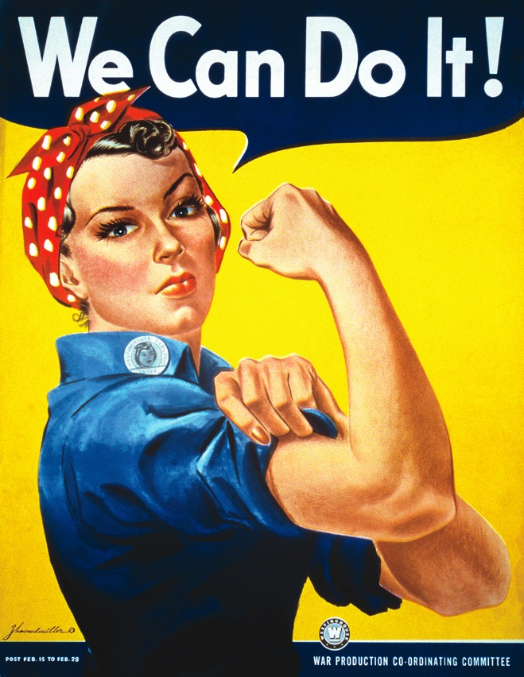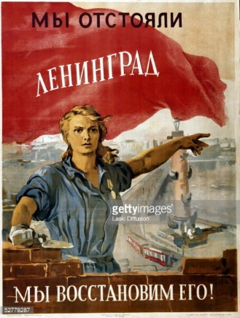
- Evaluate and analyze the Nazi propaganda poster on the board. What is the message? How is it being conveyed (visuals and text combine to create meaning). What was the purpose of the poster? One will be chosen from the gallery notes on the website.
Translation from the poster. Hinter den Feindmachten: der Juden = Behind the enemy forces: the Jews
